Artur Cisar-Erlach MA. BSc.
Michele Rumiz MSc
Ludovico Roccatello BSc.
Sifis Plimakis PhD.

Abstract
A roadmap – strategic framework with priority actions for the sustainable development of nature based tourism in Greece
Component 4.2
Nature Based Tourism

Table of Contents
Executive Summary 4
Introduction 6
Part I: Current situation 6
Nature Based Tourism 6
The case for Nature-based tourism in Greece 7
Online sites 8
Sustainability in nature based tourism 9
Environmental Sustainability 9
Social Sustainability 10
Economical Sustainability 10
Nature based tourism in Greece and sustainability: 10
Food tourism & Food heritage 11
Main stakeholders and policy’s responsibilities allocation 12
Basic legal framework 13
Laws 13
Categories of nature based enterprises 13
Financial sources for the development of nature based tourism 13
Qualitative research and stakeholders’ meetings 13
Licensing and certification process 15
Hotels - private enterprises views of culinary tourism 16
SWOT analysis 18
Part II: International best practice examples 20
“Hansik Cuisine” - South Korea 20
“Gastronomy Tourism” - Region of Catalonia, Spain 20
“Food Tourism the Slow Food Way”- Slow Food Travel 21
Slow Food Travel Alpe Adria Kärnten 22
“Holiday on the farm” - Austrian Model 23
Austrian Legal Framework “Holidays on the farm” 23
Italian Agritourism legal framework 25
Lessons for Greece 25
The Case for a Pilot Destination 26
Part III: Regional Analysis Central Greece 28
Factor 1 Details: 28
Culinary tourism in the region of Central Greece 28
Planned categories of actions by the region 28
Factor 2 Details 30
Overview Southern Euboea 30
Specific South Euboean gastronomic products 31
Food companies, restaurants 31
The case for the Pilot destination in southern Euboea 32
Additionally, promising Regions 32
Attica 32
Crete 32
Part IV: Action Plan 33
National Level 33
Licensing & Certification 33
Agrotourism 33
Promotion 33
Regional Level 33
Destination Management for Food & Nature based tourism 33
Action plan for Potential Slow Food Travel Pilot Project in Southern Euboea 34
Food Heritage 34
Conclusion & Recommendations 35
Addendum I 36
Agrotourism legal framework - region of Piedmont Italy 36
Addendum II 46
Slow Food Travel Criteria Catalogue 46

Executive Summary
Nature and Food based tourism are said to be two of the fastest growing areas in tourism, a demand that is driven by the contemporary experience economy that values uniqueness and authenticity above all. As part of the effort to diversify the Greek tourism landscape nature and food based tourism has thus been recognized as an important area that offers diversification and a prolonged tourist season. While Greece is uniquely qualified to become one of the world’s great natural Tourism destinations with its beautiful, diverse and unspoiled landscape, a strong food heritage and a varied, small scale agricultural production the situation within the existing industry is somewhat characterized by a strong fragmentation and a lack of coordination.
Research as well as stakeholder meetings revealed several problems in the areas of:
- Licencing and Certification
- Lack of a coherent model
- Absence of a specialized and distinctive certification process
- Over-complexity of the registration process
- Promotion
- Absence of a common national brand and website
- Limited promotion abroad
- Fragmented and non-coherent / coordinated promotion
- Collaboration between stakeholders
- Limited coordination between the sectors’ major stakeholders
- Demarcation dispute between the Ministry of Tourism and the Ministry of Agricultural Development and Food
Overall however the industries view is very positive regarding nature based tourism. Particularly culinary tourism was seen as a promising field and many private sector initiatives have already been implemented.
Several international best practice examples revealed that, once the right steps have been taken, by both governmental organizations and private sector stakeholders, nature and food based tourism can become a major area of growth. Essential premise however is that someone adopts a leadership role, most preferably the Ministry of Tourism.
During research, conversations with stakeholders and experts it has become apparent that an implementation of a trial destination would make a lot of sense.
An interesting opportunity for Greece, both in terms of valuable know-how and promotion possibilities, would be a collaboration with Slow Food and its Slow Food Travel concept. The area of southern Euboea in the region of Central Greece has proven to be the most promising location, due to enthusiastic support by the regional authorities and a wide range of already existing nature and food based possibilities.
Further international best practice examples show that the in Greece only marginally existing Agrotourism sector can be very successful under the right conditions.
Recommendations are therefor:
- The Ministry of Tourism should take the lead and efficiently manage the communication between all stakeholders, including relevant government departments, universities, national and international organizations and public as well as private companies
- This role should include:
- actively starting and continuously advancing the essential process of streamlining the certification and audit process for food and nature based tourism enterprises
- initiating and overseeing the implementation of a sound legal framework for Agrotourism offerings
- building a strong, unifying brand for nature and food based tourism and promoting it internationally; incorporation of cross-promotion where feasible
- actively seeking synergies to other tourism areas, particularly cultural, religious, sport (diving) and health tourism
- The Traditional Regional & Local Product Basket imitative should be expended and used as a vehicle to encourage and support producers to apply for PDO´s & PGI´s and Slow Foods Ark of taste program.
- The implementation of a Pilot Destination in Southern Euboea based on the Slow Food Travel principals is highly recommended
- Further possible pilot destinations are researched and selected

Introduction
The financial and economic crisis has exposed fundamental weaknesses in Greece`s economic model which required an immediate and major structural reform drive by the Hellenic Republic. To support a number of important reform areas the Greek Government has asked the European Union for technical support which is coordinated by the Structural Reform Support Service (SRSS). The European Commission set up the SRSS in July 2015 to help EU countries carry out reforms that support job creation and sustainable growth.
One of the areas that has been identified as being in need for improvement is tourism. The goal is to improve the framework conditions for sustainable development of tourism in general and the development of new alternative tourism products that extended the season in particular.
Under Component IV of the EU support program Nature based tourism has been recognized as an important area that offers diversification and a prolonged tourist season.
This report summarizes the current situation of nature based tourism in Greece in general, analysis the existing regulatory framework, scrutinizes previous measurements taken, compares it to international best practice examples and finally draws a draft Action Plan for necessary future steps.

Part I: Current situation
This part consists of a comprehensive overview of the current situation of nature based tourism in Greece, its regulatory framework as well as an analysis of challenges and problems identified by various stakeholders.

Nature Based Tourism
Nature and Food based tourism are said to be two of the fastest growing areas in the, in terms of growth, generally blessed tourism industry. Originally only niche products they have become highly dynamic global phenomenon’s, pursued by many destinations but only mastered by a select few.
Existing in-between the two seemingly contradictory poles of increasing globalization and enhanced appreciation for the local and traditional, they offer the possibility for the introduction of truly sustainable forms of tourism and regional development. Implemented correctly nature and food based tourism can create lasting regional value chains, that revitalize the often economically disadvantaged countryside, protect biodiversity and present new possibilities for old and young citizens alike; thereby counteracting the negative dynamics of rural depopulation. This is possible through their inherent interconnectedness, that not only involves tourism but also other economic sectors as well as the social and natural environment.
Classically nature based tourism includes wildlife tourism, eco-tourism, cycle tourism, geo tourism, adventure tourism and cruise tourism but for many food tourism also is an integral part. For people who are normally not attracted to activities in the great outdoors, food tourism can become an entry point, while for seasoned nature aficionado’s food is a way to experience it more deeply. Unfortunately, food tourism is still primarily understood as wine and high-end gastronomy tourism although it has become much more diverse than that. It encompasses everything from visits to small scale farms, food producers and fisheries to participation in cooking classes, food festivals, street food fairs and even workshops on foraging for wild ingredients and hunting. Also, the target audience has diversified greatly and spans across a wide range of cultural, social, age and income groups.
The demand is thereby driven by the characteristics of the contemporary experience economy that values uniqueness and authenticity above all. Memories, often documented and shared with the help of numerous types of technology, become the product themselves. Therefor food products and dishes with a rich local history and tradition are often favored over high-end gastronomy, even though they might be locally considered as simple or basic. The story, the quality and the experience counts, not the price. That said the food tourist is much more likely to spend more money than a typical “Sun and Beach” tourist.

The case for Nature-based tourism in Greece
With a total size of 131 621 km² spread over the mainland and 6,000 islands / islets, Greece has a rich tapestry of landscapes making it one of the Mediterranean’s most biodiverse countries. From rugged mountains to sandy beaches it offers every possible natural Mediterranean environment imaginable, whereby almost 50% of the country is covered by forests. It furthermore has 10 National Parks and the total coastline of 13 780km includes many wetlands that are protected under the EU Habitat / Bird Directive. Totaling in 202 Special Protection Areas (SPAs) and 241 Sites of Community Importance (SCI) within the NATURA 2000 network, they are prime areas of interest for nature based tourism activities. Carefully managed tourism in this areas would not only increase the funds available for the upkeep of these conservation areas but could also incentivize the formation of further conservation zones.
Greece’s agricultural industry is generally characterized by its small-scale structure due to many areas facing natural constraints. This might be a considered a problem from a purely agricultural production point of view but is actually an immense asset from a food tourism perspective. It means that there is not only a highly diversified production of often very regional specialized food products (that are extremely attractive to a food tourist) but also that a high number of farms are small-scale family farms. Both are perfect pre-conditions for farm based tourism, also called Agrotourism. However according to the 2012 agricultural census only 500 holdings out of 723 010 in total have an additional income through tourism. That is 0.07%. Considering the particular high economic importance of agriculture in Greece (3,8% of the total Gross Value Added (GVA) and 13,6% of total employment) the development of additional income sources for this sector (e.g. tourism) would benefit the countries overall economic situation considerably.
Based on the highly diverse and small-scale agricultural production Greece has many fantastic regional cuisines to offer. From the seafood and vegetable based cuisine along the coastlines to the meet, cheese and herb based cuisine of the mountains there is something new to be discovered for every food focused traveler. However, not only the potential discovery of new food delights is a strong attractor for food tourist but also the health aspect of a countries cuisine. This is where Greece’s “Mediterranean Diet” comes into its own, as it already is a very well-established, UNESCO protected, concept renowned the world over. Nonetheless, is the Mediterranean Diet not unique to Greece as it has to share the title with Cyprus, Croatia, Spain, Italy, Morocco and Portugal, who are all successfully marketing it. It is therefore detrimental for Greece to find a differentiator, a Greek version of the Mediterranean Diet if you will, that sets it apart from the other countries. One essential way to achieve this is by combining the countries incredible history and historic sites with the origination of certain food products or dishes; thereby creating a unique story. Also by finding food items that the other Mediterranean Diet member countries don’t actively promote and basing the food tourist marketing effort on them would give Greece an even stronger gastronomic image. The island of Crete with its “Cretan Diet” can be seen as a great best practice example in this instance.
Overall Greece is practically destined to be one of the great nature and food based tourism nations on this planet. As a matter of fact, does the country already have more than 5.000 enterprises operating in the area of nature based tourism. Under the stewardship of the Helenic Society for the Protection of Nature (HSPN) some 497 Blue Flag ecolabel beaches and marinas, the second highest number of such sites after Spain, have been certified. A further 233 Green Key eco-labels have been awarded to hotel providers with highly sustainable operations, the third highest number after France and the Netherlands. Also, popular booking and review sites like booking.com and tripadvisor.com list a myriad of existing nature based activities and offers that are well received by customers. In the food sector Greece is regarded as being among the Top Global Food Destinations. Only the fully immersive Agrotourism offering is somewhat small with the website of the Helenic Agritourism Federation listing only 9 participating farms and wineries.
International marketing efforts of nature and food based tourism in Greece have so far been not very coordinated and rather left to individual stakeholders. Fortunately, in the context of the UN`s International Year of Sustainable Tourism, considerable efforts have been made to represent the country’s sustainable tourism offerings in a coordinated way at the Mediterranean Panorama exposition in Sweden. With northern Europe being one of the biggest source countries for nature and food based tourists such concentrated expositions directly in the major source markets is a very good strategy.
The remarkable thing about Greece as a food destination in general is that all the necessary building blocks are already well in place. There is no immediate need for the creation of new food products, cuisines or tradition which would need large investments. What it needs is the formation of a strong, mutually supportive network between all involved stakeholders, streamlining and clarification of regulatory requirements (e.g. agrotourism) as well as a concentrated marketing effort under the lead of one actor, most preferably the Ministry of Tourism.

Online sites
A notable number of websites exists that are dedicated to informing the potential tourist on the possibilities of nature and food based tourism in Greece.
Together the Ministry of Tourism as well as the Greek National Tourism Organization (GNTO) have created the Marketing Greece SA non-profit cooperation whose website discovergreece.com has comprehensive sub-sections on nature and gastronomy in Greece. Featuring a fresh design with rich multimedia content, inviting stories by local experts and direct booking options this site is a one-stop-shop for interested tourists. Possible interesting additions to the sites content could be more videos featuring the preparation of typical regional dishes supported by a comprehensive recipe collection.
Another site run only by the Greek National Tourism Organization (GNTO), visitgreece.gr, similarly has major sub-sections on nature, gastronomy and even agrotourism. However, its multimedia content is somewhat limited and so is the overall design of the site. Merging the extensive information collected on visitgreece.gr with the rich multimedia content and fresh design of discovergreece.com should definitely be considered, as this would yet again concentrate the official marketing efforts and enhance their effectiveness.
Further private websites with extensive information on nature and food tourism include ecotourism-greece.com and agroxenia.net.
Following an initiative by the Hellenic Chamber of Hotels to display the diversity of the Greek gastronomy through a region-specific breakfast in each member hotel the website greakbreakfast.gr was born. It gives a good overview of all the different breakfast on offer in hotels throughout the country as well as showcases some of the producers and regional cuisines.
Crete has very successfully marketed itself since many years as a foody destination and can be seen as a good best practice example for the whole country. One result of the islands efforts is the website cretan-nutrition.gr that showcases and explains in detail the health benefits of the “Cretan Diet”, effectively marketing the islands own version of the Mediterranean Diet. It furthermore introduces the visitor to the other parts of the Cretan brand; namely the product label Crete, the restaurant label Cretan Cuisine and the Crete Open Winery Label. All play a major part in the Cretan successful bid for gastronomic tourists and could be similarly adopted by Greece as a whole.
- http://www.discovergreece.com/en/nature
- http://www.visitgreece.gr/en/nature/agrotourism
- http://www.ecotourism-greece.com/
- http://agroxenia.net/en
- http://greekbreakfast.gr/en/
- http://www.cretan-nutrition.gr/wp/?lang=en

SUMMERY / KEY ISSUES
- numerous online sites catering to the interested nature & food tourist
- information is varied, often overlapping and slightly confusing
- unification of several sites it recommended

Sustainability in nature based tourism
If understood literally “Nature based tourism” means nothing else then travelling somewhere off the beaten path into the natural environment. However, it is generally understood as a form of tourism that is sustainable, which means that it should have no negative effects on the environment, the local people and their cultural heritage. Far from that, it actually ought to have a positive effect. Economic development and environmental protection should thereby not be seen as opposing forces that need to be balanced against each other but rather as mutually reinforcing aspirations.
The World tourism organization defines sustainable tourism as follows:
“Tourism that takes full account of its current and future economic, social and environmental impacts, addressing the needs of visitors, the industry, the environment and host communities.”

Environmental Sustainability
Especially in the context of climate change it has become paramount for the tourism industry to become fully sustainable. After all is the environment essential to tourism success as many tourists are motivated to visit by the natural beauty of a destination. Particularly for nature based tourism, but also beach and winter tourism, climate change is a real threat as these areas are most likely to be adversely effected the first. Therefor nature and food based tourism have to be fully sustainable in its own interest, at the same time setting an example for other tourism fields.
However, due to sheer size of the industry it is often difficult to avoid negative effects particular on the environment. Those negative effects can be condensed into three main areas: Pressure on natural resources (e.g. water), Pollution (e.g. solid, liquid waste, air pollution), Physical impact (e.g. land clearing, construction, disturbance of natural environment)

Social Sustainability
Social sustainability is a key issue in tourism as unfortunately all too often knowingly or not a host community get caught in one form or another of exploitation. This can involve exploitation of their labor, their natural resources or their cultural / religious traditions. The smaller a community the more easily it is exploited. Therefore, very careful measures have to be put in place at the very beginning of a project to insure mutually beneficial results. As particularly in nature and food based tourism small host communities and their highly specific food products are one of the main attractors, their wellbeing and thriving is of the utmost importance for the long term success of the whole project.

Economical Sustainability
For a destination to be truly sustainable it has to be long term economical successful, creating a multitude of direct and indirect financial benefits for the host communities. In many cases this is however not the case due to factors such as a wrong understanding of the market, bad business decisions, strong leakage of financial resources to parties outside of the host community, very low visitor spending or weak local business networks. To increase the chance for economical sustainability many steps have to be undertaken already in the planning phase of a project but also require expert monitoring and training during and after the implementation. If successful, especially nature and food based tourism has the power to become a powerful rural development tool that alleviates the economic situation of whole communities.

Nature based tourism in Greece and sustainability:
- How to avoid negative effects on the environment?
- How to warrant social sustainability?
- How to ensure economical sustainability?
Avoiding negative effects on the Environment can be achieved through careful control of tourism development with stringent land use control, building regulations and policies that seek to minimize damage to habitats. Policy areas should include the raising of awareness through education and interpretation (both for visitors and tourism operators), stringent waste regulations as well as visitor management in ecological sensitive and protected areas. This does not mean closing off protected areas to public access but rather taking measurements that support a small but steady stream of visitors. Through the encouraging of diverse, nature-based, small-scale tourism offerings in Greece, instead of the mass-market sun and beach products dominating the field at the moment, tourists will be dispersed throughout the country and not so highly concentrated. Concentration namely is the main offender when it comes to all three areas of negative environmental effects. A prime target for the tourism diversification goal in Greece is thereby the proliferation of Agrotourism offerings through favorable policies, funding or tax incentives and a sound legal footing. This must include an adequate criteria catalogue and a streamlined registration and certification process which currently does not exist. The increased by-use of already existing homes for accommodation purposes solve the problem of an unwanted physical impact on the environment through tourism development construction.
Social Sustainability can be warranted through the involvement of host communities in every part of a nature based tourism development project. This way they are empowered and can take charge of their resources. In protected areas, this could include advocating collaboration between protected site supervising authorities and small local tourism operators and involving communities surrounding protected areas in the development of management and business plans (participatory process). Furthermore, should the volume of visiting tourist be carefully managed, and rather kept in the low numbers. This can yet again be achieved by diversification of tourism offers that are distributed evenly throughout the country and promoted accordingly. A community’s dependence on tourism only as source of revenue should be avoided. Particularly in food tourism this can be evaded from the get go, by encouraging and supporting involved producers to find further outlet markets for their products. Extensive training offerings and coaching generally should be available to strengthen the community beyond tourism. By actively encouraging the development of businesses outside of tourism, (e.g. food producers that expend outside their local market) the communities become resilient.
Economic sustainability has many parallels with social sustainability in nature based tourism as only through empowering a community it becomes a viable, long term successful tourism project. Letting the community, under careful expert guidance, develop the very tourist attractions will not only make the attractions much more authentic but will also make it economically more sustainable in the long run, as it is supported by the community. Encouraging networks between local businesses will allow for creative cross breading and the development of complete new businesses. By designing tourism offerings as full functional local units, that create a circular economy effect, the highest degree of sustainably can be reached.
SUMMERY/KEY ISSUES
- Environmental, Social and Economical Sustainability is of the utmost importance in nature and food based tourism
- Control of tourism development and a diversification of tourism offerings is essential
- Policies that educate both visitors and tourism businesses are indispensable
- Agrotourism offerings need strong proliferation
- Strong Concentration of touristic activities have to be avoided
- Including communities in the planning process is vital; Participatory Process
- Encouraging local networks to create circular economic effects is fundamental

Food tourism & Food heritage
An important factor that has to be considered in food tourism in particular, in addition to the sustainability aspects already mentioned for nature based tourism in general, is the sustainable preservation of food heritage. Food heritage defines food that is culturally or historically linked to a specific region, locality, ethnicity or traditional production practice.As a Unique Selling Point (USP) they are incredible important for the attractiveness of a destination to food tourists, and are therefore an important aspect of economical sustainability. Also under the aspects of social and environmental sustainability a strong food heritage is key, as it normally includes food items that are perfectly adapted to the local ecological and social realities.
Greece has a wealth of unique products that includes everything from Chios Mastiha to the Kopanisti cheese of the Cycladic Islands, 76 of which are protected under the EU`s Protected Designation of Origin (PDO) and 32 are under the Protected Geographical Indication (PGI) legal framework. Besides being great legal protection and product marketing tools those labels and their producer consortia are also excellent for food tourism marketing. Collaboration between PDO & PGI holding producers and regional as well as national tourism organizations (eg tourism advertisements on products labels and vis versa) would be a win-win situation for both sides. The ‘’Traditional local products baskets’’ policy initiative by the Ministry of tourism with the participation of the regional government authorities is thereby an excellent step in this direction.
Taking steps to protect the countries incredible food heritage, be it through actively supporting the application for further PDO´s & PGI´s or by working together with international organizations like Slow Food and its Ark of Taste program is therefor of huge importance for the overall success of food tourism.
SUMMERY/KEY ISSUES
- Food heritage is one of the strongest USPs to tourists
- Protection is therefore essential
- PDO & PGI as well as Slow Food Ark of Taste Program are excellent tools to do so
- Cross promotion between Food Producer Consortia and Tourism Organizations is a win-win for both sides

Main stakeholders and policy’s responsibilities allocation
An analysis of the stakeholders for nature based tourism in Greece shows that the responsibilities are spread across several ministries, chambers, regional and local entities as well as associations. In a tourism field as interconnected as nature based tourism this is an expected result and similar to many other countries. Particularly the certification process of nature based tourism enterprises however is extremely complex as it involves all main stakeholder. This is certainly an issue that needs to be addressed as it raises the entry bar for interested enterprises extremely high.
 | National Tourism Strategy | Regional Tourism Strategy | Local Tourism Strategy | Certification of Nature based tourism enterprises & products | Financing  of tourism enterprises | Registration of tourism enterprises | Registration  of agro based associations, cooperatives and nature based tourism enterprises
Ministry of Tourism | X |  |  | X | X | X
Ministry of Agricultural Development and Food |  |  |  | X | X |  | X
Ministry of Development |  |  |  | X | X
Regional Government Authorities |  | X |  | X | X
Local Government Authorities |  | X | X | X
Greek Tourism Confederation | X |  |  | X
Greek association of nature based tourism enterprises | X |  |  | X
Greek Hotels Chamber | X |  |  | X

Basic legal framework

Laws
Law 3874 / 2010 | Regulation of nature – based tourism
Law 4179 / 2013 | Simplification and promotion of tourism policy
Law 4314 / 2014 | Management and allocation of European Union Structural Funds in Greece

Categories of nature based enterprises
- Rooms to rent
combined with nature based tourism activities and traditional products
- Traditional farms
combined with the provision of nature based tourism activities
- Processing of farm products
- Catering of traditional food products
- Restaurants
providing traditional Greek / local cuisine, based on natural local products
- Selling of traditional Popular art and other products
- Traditional handicraft products

Financial sources for the development of nature based tourism
- EU funded National rural development program
- Leader + program & actions
- CLLD program + actions
- EU Structural Funds, provided from the Regional Structural Funds
- Development law for the start-up of new private enterprises and the upgrade of existing enterprises’ facilities
- Public – Private Partnerships funds
- Local government funds

Qualitative research and stakeholders’ meetings
Qualitative research as well as stakeholder meetings conducted by Dr. Sifis Plimakis revealed that particularly in the area of culinary tourism Hotels and Private Enterprises see a huge potential for nature based tourism in Greece. However, the meetings also revealed several problems in the areas of certification, collaboration between stakeholders, implementation of policies and promotion.
- Previous years policies and initiatives for the development of nature based & gastronomic tourism were particularly ineffective, characterized from the wastefulness of the provided funding
- Serious corruption and maladministration problems during the previous years’ regarding the certification and the financing of the nature based enterprises
- There is still a limited interconnection between the local agro-production and Greek rural tradition with the tourism sector
- Appearance of serious disagreements and disputes regarding the legal definition and status of nature based tourism enterprises, both for the local - small enterprises and the big hotels & hotel associations
- Appear of a regulatory complexity and overlaps regarding the certification and audit of nature based & gastronomic tourism enterprises
- Limited coordination between the sectors’ major stakeholders, the ministry of tourism and the Ministry of Agricultural Development and Food
- A ‘’competition” among the ministry of tourism and the Ministry of Agricultural Development and Food for the ‘ownership’ of nature based & gastronomic tourism enterprises certification
- Existence of a ‘’cultural gap’’ between the ministry of tourism and the Ministry of Agricultural Development and Food, especially at the area of the services should be provided from nature based & gastronomic tourism enterprises
- Important problems at the multi-level implementation of the nature based & gastronomic tourism policy
- Limited audit capacity of the involved public agencies for the control and supervision of agro-tourism sector enterprises performance and compliance with the required services standards
- Problems regarding the lack of effective and attractive tax incentives and tax exemptions for nature based tourism enterprises
- Absence of certification of nature based tourism enterprises, due to the non-publication of agro-tourism enterprises operational & building specifications and standards
- Problematic / lack of certification for sector’s enterprises due to the non-publication of the necessary joint ministerial decisions, 3 years after the publication of law for the regulation and registration of nature based & gastronomic tourism enterprises
- Certification of nature based & gastronomic tourism enterprises according to a temporary, incomplete and ineffective system of registration.
- Important problems at the performance of the nature based & gastronomic tourism registry, which are due to its limited support from an IT system and the incompleteness of the standards
- The certification standards of nature based & gastronomic tourism enterprises are not at the same high level required by the market, standards for the provided services of enterprises
- Lack of specialized standards for the certification of traditional Greek food dishes provided at the hotels and restaurants in tourist areas
- Limited interest and participation of nature based & gastronomic tourism enterprises at traditional Greek food certification system
- Appearance of different & competitive certification systems for Greek traditional cuisine & gastronomic tourism enterprises in Greece. For example:
- The trademark / certification of traditional quality Greek cuisine, provided by the ministry of tourism
- The trademark / certification of traditional quality Aegean cuisine, provided by the regional authority of South Aegean
- The trademark / certification of traditional quality Cretan cuisine, provided by the regional authority of Crete
- The covenant of Cretan Breakfast for the hotels, provided by the Greek Hotel Chamber
- The covenant of Greek breakfast for the hotels, provided by the regional authority of Crete
- Limited promotion abroad of Greek nature based tourism enterprises and products
- Fragmented and non-coherent / coordinated promotion abroad of Greek nature based tourism, based on the individual participation of stakeholders and associations at international exhibitions
- Absence of a common national site for the promotion abroad of Greek national based tourism

Licensing and certification process
Particularly the licensing and certification process for nature based tourism enterprises revealed a host of problems:
- Lack of a coherent model / system for nature based tourism enterprises certification and registration / appearance of different, competed, overlapped and incomplete certification systems
- Absence of a specialized and distinctive certification process for nature based tourism enterprises, due to the non-publication of the certification standards from the ministry of tourism and the ministry of rural development
- An over-complexity of the registration process:
- Registration and certification of nature based enterprises at the national tourism enterprises registry of the ministry of tourism, with the addendum of additional standards
- Registration and certification of nature based tourism enterprises at rural enterprises registry of the ministry of rural development, in order to be eligible for funding from Leader + / CLLD EU program
- Registration of nature based tourism association and cooperative at the enterprises registry of the ministry of rural development

Hotels - private enterprises views of culinary tourism
- They are very interested in the incorporation of culinary tourism products
- They believe that there are a lot of prospects for the development of culinary tourism in Greece, but there is a lack of an effective national policy
- An important problem facing the development of culinary tourism in Greece, is the lack of an effective policy and standards for the certification of agro-tourism enterprises in Greece
- State should create and promote an internationally competitive trademark for Greek food, in collaboration and consultation with tourism sector enterprises and the producers
- Participation to these trademark – certification should be in a voluntary base
- For the promotion of culinary tourism in Greece, a certification program should be created and promoted
  - At international level
  - At regional level
  - Including raw food, herbs, traditional dishes and formulas
  - Including not only food dishes, but also products for crockery shops
- It’s an urgent need to create and promote at international level a strategic & marketing plan for Greek culinary tourism
- The GNTO should organize and provide a specialized campaign for culinary tourism in Greece, in collaboration and with the participation of the various tourism enterprises association’
- The majority of culinary tourism initiatives, are based on private sector interest with a limited contribution from the state
- National culinary tourism products with a potential important demand at international level – indicative:
  - Wine
  - Traditional drinks as raki and tsipouro
  - Pies
  - Olive oil and olives
  - Marmalade
  - ‘spoon sweets’’
  - Rusks – crackers
  - Herbs
  - Beverages
- A lot and a fast-growing number of Hotel enterprises have incorporated various culinary tourism products as:
  - Traditional breakfast
  - Traditional dishes
  - Wine and traditional drinks
  - Olive oil, Herbs, Honey, Marmalade – jams
- An innovative approach for the promotion of culinary tourism in Hotel sector is the provision – organization of visits to local farms, crockery shops and family – small scale units, in order visitors to have the opportunity to see and participate to food’s production
- Create a story telling and a narration behind every culinary tourism product
- A very crucial role for the promotion of culinary tourism in Greece, plays the creation of regional / local producers – enterprises networks, emphasizing in young and innovate producers and entrepreneurs
- For the promotion of culinary tourism products in Hotels, it’s necessary to:
  - Establish partnerships and synergies between the producers and the Hoteliers
  - Certify their production and producers compliance with certification standards
  - Training the producers
  - Guarantee the supply of the products, according to the demand
  - Products to have a high quality
  - Incorporate products in snacks form and other forms of food
  - Creating a story behind every products, that will associated it with the local history and tradition, everyday life in the past years and also present its nutritional value
- It’s very important for the visitors to know and be informed regarding where they can find these products in their country of origi
  - Development a national site for culinary tourism providing these information
  - Organization of an international / national network of selling points / shops
  - Development of an identification and information provision application, based on products’ barcode, regarding where they can find these products in their country of origin

SWOT analysis
Strengths
- Very important and distinctive local cultural tradition
- Existence of many places characterized from natural beauty
- Differentiated geological morphology, combined sea and mountain place
- Very good weather conditions, ideal for the development of whole year tourism / four seasons tourism
- Plenty of environmental protected natural areas
- High quality and distinctive food tradition
- Important differentiation of food tradition among the different regions
- Local food tradition based on Mediterranean diet
- Healthy local food tradition and cuisine
- High quality local food products
- Very important traditional in traditional handicraft products

Weaknesses
- Lack of a coherent national policy for the promotion of nature based tourism
- Marketing and promotion problems
- Stakeholders coordination problems and gaps
- Limited attractiveness of Greek nature based tourism to foreign visitors
- Domestic tourism orientation
- Absence of coherent and competitive nature based tourism products
- Accessibility problems
- Limited international connections
- Poor infrastructures
- Lack of certification
- Limited interconnection of nature based tourism with traditional food and wine products
- Corruption and maladministration problems
Opportunities
- Growing international demand for nature based tourism
- Very important prospects for the development of nature based tourism, especially food and wine tourism
- Important private sector and local government initiatives during the last five years, for the development of nature based and food and wine tourism in Greece
- The international publicity and recognition of Mediterranean diet and cuisine, the base of Greek food tradition
- Recent developments in low – budget air - connections in Greece
Threats
- International competition
- Financial crisis impact on Greek economy and society
- Geopolitical instability in south – east Mediterranean
- Limitation of state and EU funding for nature based tourism
- Problems of air – flights connection and international accessibility of many and the major nature based tourism areas

Part II: International best practice examples

“Hansik Cuisine” - South Korea
- Focus on healthy aspects of Hansik (Korean Cuisine)
- Passing of a government-funded Hansik Foundation Act
- Inauguration of Hansik Globalization Development Agency with members from relevant Government departments, academic institutions and food industry CEOs
- Korean Tourism Organization developed gastronomic tours in collaboration with top Chefs, Gastronomists and Korean Entertainers.
- Celebrity Promotion as well as combination of gastronomic culture with TV shows
- Korea tourism website offers comprehensive introduction to local delicacies and food products, as well as Korean table manners.
- Ministry of Tourism developed tourism products that allow guest to participate in the making of traditional food products
- Oversees Korean Culture Centers and Plazas are used to offer cooking classes, showing of video & photos that promote Korean cuisine, distribute promotional material and sponsor events for visitors.
- The highly successful Korean Pavilion at food themed World EXPO 2015 in Milan, was completely devoted to Hansik and its artistic interpretation.

“Gastronomy Tourism” - Region of Catalonia, Spain
- In seeking to diversify tourism away from “Sun & Beach”, Gastronomy tourism was identified as a promising field
- First Step:
Catalan Tourist Board created the Gastronomic Cub, consisting of three categories of members.
Group A: Service Providers
Group B: Tourist Promotion Companies
Group C: Partners (Universities etc. active in the field of tourism research)
- The Club allows companies to participate in Catalans strategies for tourism promotion.
- Results from the Club are shared with all members of the Catalan Tourism Board. They include marketing materials, a professional advisory service, participation in the Clubs forum for tourist professionals and use of tourist promotion centers abroad.
- Second Step:
Directorate General for Trade founded Gastroteca, a website providing promotional and marketing support to local food producers that is also a source of information for consumers and tourists.
- Gastronomic Club and Gastroteca have designed 27 tourist routes for consumers that are interested into tasting local food products
- Additionally, Catalonia profits from the strong impact its famous chefs (Ferran Adrià, Carme Ruscalleda, Roca Brothers) have on worldwide media.

“Food Tourism the Slow Food Way”- Slow Food Travel
Slow Food
Slow Food is a global, grassroots organization, founded in 1989 to prevent the disappearance of local food cultures and traditions and counteract the rise of fast life. Since its beginnings, Slow Food has grown into a global movement involving millions of people in over 140 countries, working to ensure everyone has access to good, clean and fair food. An umbrella organization that has the role to guide and steer the action of the entire movement made of over 1,500 local chapters, 2,000 food communities and reaching every year millions of people. Slow Food envisions a world in which all people can access and enjoy food that is good for them, good for those who grow it and good for the planet.
The Slow Food Travel project
Slow Food Travel is a Slow Food project whose aim is to develop and promote a travel experience that is in line with the Slow Food philosophy. The Slow Food Travel project consists of different components that can be represented graphically as an onion.
At the centre of the project are food and food production. Unique and biodiverse gastronomic identities constitute the heart of the project and underpin all its activities, interlinking the various attractions at the outer layers. The latter include osterias, agriturismi, restaurants, inns, bars and leisure venues, and connected activities such as fairs, events and food and wine tastings. The result is a convivial community that interacts and works as a system, welcoming visitors who discover it through food. The project seeks to develop tourist itineraries and services through the promotion of local cultural, agri-food and gastronomic biodiversity, thanks to the participation of visitors (visits to food companies and farms, tastings, events, etc.). Its ultimate goal is to educate and raise awareness among visitors about the conservation of biodiversity and cultural heritage, identities and local gastronomy, as well as to develop connections between virtuous businesses in different locations in order to spread a more sustainable model of tourism.
Slow Food Travel is a project of Slow Food International. As a matter of course, it involves one or more Slow Food Convivia (or other local bodies recognized by Slow Food) in the area. Moreover, it should involve:
- Local institutions (in particular the local tourism organization and/or those responsible for tourist/cultural activities);
- Food producers, restaurateurs, hoteliers, etc. in the local area;
- Civil society entities interested in the project (social and cultural associations, other bodies etc.).

The foods promoted by the Slow Food Travel project are traditional, typical of the area and artisanal. They come from local production chains, using ingredients that are grown or raised in the local area of the project, which gives them a specific identity.

Slow Food Travel Alpe Adria Kärnten
Slow Food Travel Alpe Adria Kärnten represent the first experience of Slow Food Travel destination worldwide. It is the result of the collaboration between Slow Food International Headquarter and counsellors, the local convivium of Slow Food, Carinthia and is bookable via NLW Tourismus Marketing.
It has been the pilot for the project and represented 3 years of fieldwork developing the networking, training and communication activities. The project development meant active participation of local actors, knowledge transfers between them, and good, clean and fair products from local farms for the visitors. A bridge is being built between the guest and the region and an awareness for things worthy of preservation is fostered through cooking courses, behind-the-scenes tours and cooperation between the food and drink producers.
With the Alpe Adria Kärnten Slow Food Travel pilot project, Carinthia and Slow Food International created the basis for a model of a travel concept which is being planned worldwide. The criteria for slow food travel are also being summarised in a handbook so that they can be internationally viable for all regions. Sustainable tourism products and services and involving travellers in food production should ensure a lasting added value for the destination.
Hotels, guest houses and boarding houses are happy to accept and partake in the cooperation. One example here is the ‘Slow Food Travel Breakfast’, which was developed by Barbara van Melle, the director of Slow Food Vienna and coordinator of the project. Slow Food travellers can enjoy regional cheese, ham, organic eggs and herbal teas, sourdough bread and handmade rolls, farm-fresh butter and local jams at breakfast. If the lodging establishment in question allows it, the Slow Food Travel Breakfast will be served at the table.
The project currently involves 14 producers and 5 hospitality facilities (bio-hotels, b&B).
The project partners
- Slow Food International
- Slow Food Vienna
- Alpe-Adria Slow Food Convivium
- ARGE Slow Food Travel business cooperation (5 leading enterprises)
- Kärnten Werbung Marketing & Innovationsmanagement GmbH
- Austrian Federal Ministry of Science, Research and Economy
- Nassfeld / Lesachtal / Weißensee Region
- Lesachtal Valley Tourism Association
- Kötschach-Mauthen, Dellach/Gail, Kirchbach
- Leading producers, hosts and hotel operators

“Holiday on the farm” - Austrian Model
Statistics
In Austria farm holidays are an important economic segment both in agriculture and tourism. Some 10.000 farmers offer more than 114.000 beds to tourists, which represents 1/7th of the total Austrian supply of tourist beds.
Two thirds of the farm holidays providers are thereby located in the mountainous regions, which allows tourist to combine skiing holiday with living on a farm.
Membership
Roughly 30% of the farm holiday providers are members of the association and brand “Urlaub am Baunernhof / Holiday on the Farm”.
To become a member a farmer has to run a “living farm”, meaning he has to be member of the chamber of agriculture and guest rooms / apartments have to be located on the farm. Furthermore, a minimum of 5 homemade products have to be offered to the guests and the farm has to reach at least the two-flower standard in the farm-holiday grading system.
The mandatory grading system is based on a criteria catalogue that takes into account:
- Farm Quality
- Facility Quality
- Service Quality

A membership fee that depends on the number of beds a provider offers allows the farmer to use the “Holiday on the Farm” brand. Marketing instruments like brochures and an internet presence do cost extra.
Structure
The association is structured into 8 Provincial Farm Holiday Associations that are coordinated by the Federal Austrian Farm Holiday Association. For training, know-how, marketing and promotion purposes the association is thereby closely connected with Austrian Tourism organisations, the Chamber of Agriculture as well as the Ministry of Agriculture.
These strong connections allow the offering of in depth consultancy services as well as training and education to all members.
Organisation / Service Centers
In order to increase the efficiency of the association and concentrate the available human resources so called “Service-Centers” have been formed. A Service-Center consists of 3-5 people from both the federal and provincial association that together work on one special task, developing it for the whole association. The results are then presented to the decision-making body before they are made available or are mandatory introduced for all members.
Examples for Service-Centers are: Brand Service, E-Service, Training & Education Service, Member Service, Quality Service, Booking Service

Austrian Legal Framework “Holidays on the farm”
In Austria, the letting of rooms in an agricultural setting is exempt from the Trade, Commerce and Industry Regulations Act if they are operated as a side-line business, therefore do not constitute the main domestic work of an agricultural business.
The exemption thereby differentiates between Privately Rented Rooms and Holiday Homes / Apartments.
Privately Rented Rooms
- A maximum of 10 beds
- Rooms rented should be part of the House/Farm and should have been (previously or partly) used by regular members of the household.
- Work invested isn’t the main domestic work (on average)
- Work is only done by regular members of the household (can include housemaids)
- The external appearance of the business has to be agricultural (can’t resemble commercial lodging establishment / hotel)
- Full board (hot and cold meals) partly or fully made from food products made on the farm (including non- and alcoholic beverages) can be provided at predetermined times if there is no possibility of selection (eg. menu).
- Additional services such as playgrounds, sauna and fitness areas, tv-rooms or general recreation rooms can be provided if they do not have obvious commercial dimensions and are also used by regular members of the household
Holiday Homes / Apartments
- Includes only the letting of Holiday Homes / Apartments with necessary amenities like bedclothes, towels, tableware, tv etc. as well as general upkeep and final cleaning
- Additional services such as playgrounds, sauna and fitness areas, tv-rooms or general recreation rooms can be provided if they do not exceed the typical size for domestic use
- Providing of any food, daily cleaning services, offering of non-domestic facilities (indoor swimming pools, tennis or squash courts etc.) or a reception service is not permitted

Also, several other activities interesting for “Holiday on the farm” providers are exempt from the Trade, Commerce and Industry Regulations Act.
- Private Lessons like Riding, Skiing, Dancing, Sailing, Driving etc.
- Seminars (eg forest related education, living on a farm etc.)

Italian Agritourism legal framework
As regulations differ by region, the northern Italian region of Piedmont has been chosen as an example. The full legal text with translations in the relevant parts can be found in Addendum I, however the following are the Key principles regulating Agritourism in Italy:
- Priority of the agricultural activity over the agritourism activity, which is demonstrated either by the higher overall time dedicated to the first, or by the higher income generated by the first;
- Subsidiarity of the agritourist activity, which means that tourism must be directly linked to the cultural, environmental, social, and human capitals generated by the agricultural activities. The best example is that of the proximity between the 2 activities, which need to take place in the same area and in an interrelated way;
- Small-scale service – Agritourism regulations limit the number of overnight guests, as well as that of people who can eat onsite the food therein produced;
- Promotion of short food supply chain – that starts by the preference of self-produced food and beverages over locally produced one; and by the preference of locally-produced food over products of regional origin;
- Respect of local landscape - Agritourism should take place in existing buildings within the farm, and not in newly ad hoc established one;
- Respect of hygiene and security – Agritourism should respect the minimum hygiene and security requirements as defined by the law;

Lessons for Greece
Based on the preceding international best practice examples, it becomes clear that a broad collaborative effort of all involved stakeholders is indispensable for a successful development of nature and food based tourism. This collaboration between relevant government departments, universities, national and international organizations and public as well as private companies seems to work best when the national tourism organizations takes the lead and efficiently manages the communication between all stakeholders. It must subsequently develop a strong brand that either consolidates many of the pre-existing ones or acts as an unmistakable umbrella brand. As soon as the brand exists all national and international communication and marketing activities for nature and food based tourism are done solely under this brand, thereby multiplying their effectiveness considerably. A dedicated website that functions as an information and resource platform for both, interested tourists and food tourism stakeholders is key and so are universally adopted comprehensive certification guidelines.
Marketing and Promotion efforts can be further boosted by collaborating with Greek companies that already have internationally well-known food products on the market. Furthermore, working with famous Greek chefs, their restaurants and other persons of public interest both at home and abroad will help to boost the country’s image as a foody destination. Also, the effectiveness of working with food bloggers and videographers shouldn’t be underestimated in this respect, as some can reach very large audiences, particularly in the younger demographic. Further positive international attention can be secured by actively working with organizations and initiating projects that seek to find solutions for contemporary problems (climate change, loss of biodiversity or even the refugee crisis) through sustainable tourism.
One such organization is Slow Food who is actively working on many of the previously mentioned problems and has experience in the establishing of nature and food based tourism. Implementing a Slow Food Travel pilot destination not only allows all involved stakeholders to gain valuable know how and discover previously unconsidered problems, but also enables involved parties to tap into the considerable marketing resources available to the organization. Additionally, Slow Food has already developed a comprehensive criteria catalogue for nature and food based tourism, which could be used as a template.
Increasing the attractiveness of becoming a Agrotourism business to farmers, through a host of measures starting with a clear legal definition, would greatly increase the attractiveness of Greece to nature and food tourists. Furthermore, has Agrotourism the unique possibility to serve niche markets in tourism like the growing accessible tourism.
Finally, it is advisable to clearly define the target audience for nature and food based tourism in Greece. Although this form of tourism has the potential to reach a highly diverse range of cultural, social, age and income groups it makes sense to focus the promotional efforts on countries with a mature economy, whose citizens see luxury in experience, self-fulfillment and well-being. They are the ones most likely to be interested into experiencing the varied Greek countryside, its many cultural and pristine nature hotspots and the numerous distinct food products and dishes produced there.
SUMMERY / KEY ISSUES
- International best practise examples show that a broad collaborative effort between all stakeholders is needed, however one has to take the lead
- Collaboration with well-respected international Organizations like Slow Food can be very valuable, both for know-how and marketing efforts
- Agrotourism offerings are an important part of nature and food based tourism

The Case for a Pilot Destination
During research, conversations with stakeholders and experts it has become apparent that an implementation of a trial destination would make a lot of sense. Having a sustainable food and nature based tourism pilot destination would not only produce valuable know-how for all involved parties and uncover many previously unconsidered hurdles but would also be a welcome result for a so far purely theoretical endeavor.
Expected results thereby include a clear understanding of the exact regulatory and certification hurdles faced by various businesses and organizations operating in this field as well as concrete concepts for new or amendments to existing policies that strengthen food and nature based tourism in Greece. Moreover, will it become discernable which Small and Medium sized enterprise (SME) support is needed to encourage business to flourish in this emerging tourism field. Also from a purely marketing and brand building point of view such a destination could be an excellent initial point to start large campaigns from and to demonstrate the concept to industry.
Furthermore, such a fully developed pilot destination would be a great model that then can be used as a template for the development of further destinations all over the country, greatly reducing the individual development costs and the chance for failure. Last but not least is it always easier to convey the concept for sustainable nature and food based tourism as proposed in this report to interested parties if you have something concrete to show.
As for the type of pilot destination a cooperation with Slow Food and its Slow Food Travel concept (as included in the international best practice examples) would be great choice as it has several advantages to offer.
Slow Food Travel has so far developed a successful pilot destination in Austria and is currently reviewing several possible further pilot sights. Greece has the opportunity to be at the forefront of this development and gain greatly from the organizations international reputation, as well as its vast experience in preserving food heritage and establishing sustainable tourism, developed on-site through an inclusive, participatory process. Essential to its approach is thereby the creation of a sustainable circular economy, by encouraging networks and synergies between local agro-food and tourism businesses. This will ensure that a destination is long-term successful, also beyond the field of tourism. Additionally, Slow Food already has not only developed a comprehensive criteria catalogue for nature and food based tourism (Addendum II) but also a whole step-by-step process for the establishing of a destination. So, they are effectively already providing a working template to follow, paired with considerable marketing resources.
SUMMERY / KEY ISSUES
- The establishment of a pilot destination would have many advantages:
- know-how, uncovering of regulatory and certification hurdles, clear concepts for new policies
- Excellent marketing tool, basis for campaigns
- Template for further destinations
- Cooperation with Slow Food and its Slow Food Travel concept would be beneficial

Part III: Regional Analysis Central Greece
After a lengthy process based on quantitative research, conversations with stakeholders & experts followed by an intensive on-site visit the Region of Central Greece has turned out to be the place with the highest potential for the implementation of a representative Pilot destination based on the Slow Food Travel principles. The selection was based on two main deciding factors:
Factor 1: Strong political interest and will by the Regional Authority.
Factor 2: A nearly perfect location in southern Euboea, that not only has to offer a beautiful and diverse natural landscape (large parts of which are part of the Nature 2000 network) and a host of unique food producers but also a local leading figure, Mr. Nikos Lagonikos, who impressively has already done much of the groundwork needed.
Furthermore, is the area somewhat disadvantaged with a Regional Social Progress Index (RSPI) of 52,6 and rather off the beaten pass in terms of tourism with only 1.6 million nights spent by residents and non-residents. This makes it an excellent proofing ground for sustainable food and nature based tourism as the revitalization of rural areas is what it is fundamentally about.

Factor 1 Details:

Culinary tourism in the region of Central Greece
- There is a very strong political interest from the regional authority for the development of culinary tourism
- Culinary tourism in combination with cultural tourism, it’s the priority for the tourism development of the region of central Greece
- They want the region of Central Greece to be famous at international level for culinary tourism
- Also, they have as a priority to be a culinary tourism destination for 1 – 2 days break for international visitors from Athens, combined with their visit to cultural monuments
- Preparation and implementation of a regional action plan for the promotion of culinary tourism in the region of Central Greece
- Incorporation of specific actions and programs at the Region’s regional operational plan for the development of culinary tourism
- Indicative budget 10 million euros

Planned categories of actions by the region
Development of 8 regional wine routes
Combination of wine routes with visits at wineries and the promotion of local products as traditional cheese, honey, pies and tsipouro – a type of raki / traditional Greek drink
Development of 8 regional food routes
Combination of food routes with cultural tourism and visits in places where the food is produced like farms and small production units. Additional training of the owners and the staff in culinary tourism
Certification of traditional cuisine - Creation of the food ‘Atlas’ of the region of Central Greece
- Registration, Description and Certification of traditional foods and food formulas
- Interconnection of these traditional foods and food formulas with specific routes and places in the region
- Publication and promotion of food Atlas
Certification of traditional products – indicative
- International certification
- For some of these products the certification will be according to EU ‘’protected area of origin’’
- E.g.: Types of local cheese, Pies, Honey, Herbs, Sippets
Development of a regional ‘’food basket’’
- In collaboration with regions agro – food synergy
  - The region of central Greece
  - Municipal authorities
  - Regional and prefectural hotel associations
  - Regional and local agro – business associations
  - Local producers associations
  - Regional and prefectural chambers of industry and commerce
  - Regional and prefectural restaurants association
- A ‘’ basket ‘’ of local food products for every prefecture of the region
Development of a certification for the provision of Region’s traditional food
- Restaurants
- Crockery shops
- Hotels and other accommodation enterprises
  - Traditional breakfast
  - Dinner and traditional plates
- Certification of food:
  - Producers
  - Raw food materials
  - Preparation and cooking
  - Serving
- Organization of training events for restaurants and crockery shops staff
- Promotion of the certification
Development of handicraft entrepreneurship, based on culinary tourism
- Action’s budget around 3 million euros
- Identification of priorities in the sector
- Selection of specific products
- Specialization of products, production, procedures and standards
- Provision of financial resources from the regional operational plan
- Financing of existing and creation of new handicraft enterprises
  - Small and family enterprises
  - Cooperatives
  - Social enterprises
- Organization of training activities
- Provision of marketing and networking services
Culinary tourism promotion
- Development of a regional marketing plan for culinary tourism
- Development of brochures and information material for culinary tourism
- Promotion of region’s traditional food certification
- Organization of press trips for culinary tourism journalists and bloggers
- Participation in international exhibitions and roadshows for culinary tourism
- Organization of promotion activities and partnerships with international tour operators, culinary tourism tour operators, airlines etc
Promotion of agro – business and producer’s interconnection with tourism enterprises
- Creation of a synergy – partnership among agro – tourism sector enterprises
- Selection of specific products for promotion and provision through the hotels and tourism sector enterprises
- Organization of training activities for the producers
- Establishment of traditional products supply chain and logistics
- Provision of specific food plates and snacks according to these products
- Standardization and certification of products production according to region’s trademark
- Creation of open – visit farms and enterprises for visitors, where they will have the opportunity to see or to participate to food products production and preparation

Factor 2 Details

Overview Southern Euboea
South Euboea is a hidden treasure of the Aegean Sea, often neglected by mass tourists, and yet located only one hour by ferry from Athens International Airport.
Its potential lies not only in the beautiful beaches and costs – a feature shared by most Greek islands. The island offers an outstanding countryside too, with high mountains (Mount Ohi reaches 1399 metres a.s.l.), numerous gorges (Dimosaris gorge, Archaboli gorge, Charakas gorge, Stropones gorge, Nileas gorge), mountain paths, waterfalls (such as the Drymonas falls), and chestnut forests (Kastaniotissa). These features make South Euboea a perfect destination for nature based tourism.
The beauty of the nature is sided by the beauty of man-made archaeological and historical sites, such as the Acropoli of Styra, the stone houses of Kymi, and the so-called Dragons’ houses - neolitic buildings built with massive stone blocks without mortar and large stone slabs for the roofs.

Specific South Euboean gastronomic products
Tiropitari (litteraly cheese pie) is a very silky dough made of just water and flour, who is first spread so to obtain a circular sheet of dough. The dough is then folded and filled with a mixture of raw egg yolk and touloumotiri, and then deep-fried.
Kourkoubines are a type of pasta made just from water and flour. Local dwellers claim that the softness of the dough is due both to the quality of water from Ohi mountain, and of the flour produced in the gentle hills of the village of Psachna (central Euboea). The dough is stirred into thick cilinders, and then cut into gnocchi/dumplings size. Each piece is then skilfully twisted on so to gain a shape that resembles that of a small ear.
Touloumotiri - a cheese belonging to the family of bagged cheeses, diffused from Anatolia to Bosnia. The name is a compound between the words “touloum” (goat- or sheepskin) and “tiri” (cheese). Once diffused in the Peloponnese, Attika and Central Greece, there are increasingly fewer producers dedicated to making this ancient cheese. Among them is a group of families in the pastures surrounding Ohi mountain. Traditionally, the cheese produced itself, without the addition of rennet, when the milk was placed in accurately washed and salted animal skins. Nowadays, however, touloumotiri is produced with equal amounts of raw sheep and goat’s milk (the percentages may vary according to availability), which are heated in big cauldrons, after which rennet is added and the fire put out. Once formed, the curd is cut into rough pieces and placed in a piece of fabric and left to drain. When served, it is usually broken in small pieces, and it is then called Myzithra.
Kefalotiri - is a hard, salty white cheese made from sheep milk or goat's milk (or both). Kefalotyri can be consumed as is, fried in olive oil for a dish called saganaki, or added to foods such as pasta dishes, meat, or cooked vegetables, and is especially suited for grating. Although spread across Greece and Cyprus, we have found in Euboea a very interesting type of Kefalotiri made from raw milk obtained from milk and goats freely grazing in the mountain pastures of mount Ohi.
Mountain wild capers – considered a delicacy by local dwellers.
Fish – Karistos hosts one of the biggest fishing flotilla of the west Aegean, and it is possible to source both fresh fish and farmed one.
Southern Euboea is also known for its wine made from the grape variety Savatiano, and olive oil production.

Food companies, restaurants
Dardouma is an artisan shop and food processing unit located in Velos. Their major product is trahana made from raw materials sourced locally. Trahana (sometimes referred to as tarhana) is a dried food based on a fermented mixture of grain and yoghurt or fermented milk, usually made into a thick soup with water. It is a common dish across the eastern Balkans, Anatolia, and Iran, but its ingredients vary very much according to each geographical region. Often produced at home, it is an excellent example of artisan and traditional product. http://www.traxanas.gr/
Melissourgion (melissourgion.com) is a honey producer located in upper part of South Euboea, offering a wide set of honey from forest and meadow flowers, raning from wild thyme to heather, from oak to raw pine tree.
Karystos yogurt and creme shops – there are still 3 shops selling home-made yogurt from animals raised in mount Ohi.
Montofoli – a very ancient roman villa located in the outskirt of karystos, transformed into a wine estate. Franks, Ottomans and Kings have given this piece of land its exceptional energy. The Estate has a panoramic view to the sea and a very rich land, both of which have made it a point of reference throughout the long history of Karystos.
Oi Moyries, restaurant located in Paradisi, a small village in the hills surrounding Marmari. This family-run restaurant is a masterpiece for food travellers, offering a wide selection of South Euboea gastronomy. Own made wine and raki, together with the shade provided by old mulberry trees (once used to raise silk caterpillar), provide the perfect retreat from summer heat.
Taverna I Apolafsis Sto Potamaki – a traditional tavern located in the city centre of Karystos, offering a great selection of traditional food from the Aegean region, served in the traditional “a buffet” manner.

The case for the Pilot destination in southern Euboea
What sets Southern Euboea apart from other considered destination is not only the support of the regional authorities but most importantly the effort that has already been put into the development of small-scale, sustainable nature and food based tourism offerings by the owner of South Euboea Tours, Mr. Nikos Lagonikos. During an on-site meeting, he demonstrated an incredible diversity of sustainable small-scale tourism offerings that he has already up and running. This include hiking and biking tours through beautiful natural areas with stop overs at local food producers, small scale hotels and cultural interesting sites as well as explorations of gorges and ancient forests. He furthermore has developed an extensive network between local food producers and tourism business and offers several food experiences to tourists. Additionally, he is even active in the training and education of young people wanting to work in the tourism industry.
Altogether he has developed an astonishing local network that would be essential in the development of a Pilot Destination; a project that would have his full support

Additionally, promising Regions

Attica
Meetings with representatives from the regions of Attica revealed many possibilities for the development of nature and food based tourism. Several of which would be an ideal day or half-day trip offering for food interested city tourist as most can be easily reached from the centre of Athens. A particularly interesting possibility was the option for people waiting at the airport to visit wine and olive oil producers for short tours, right next to the airport in Spata.

Crete
The regional authorities of Crete were also very interested into the concept of a pilot destination for food and nature based tourism, as they already have a fair bit of success and experience in this field.

Part IV: Action Plan
A roadmap for the sustainable development of nature based tourism in Greece.

National Level

Licensing & Certification
The Ministry of Tourism puts together a team to take a leadership role in the reform of the certification process for nature based tourism enterprise. This will include:
- an in-depth analysis of the full current certification & audit process thereby working closely with all stakeholder (particularly the Ministry of Agricultural Development and Food)
- delivery of a comprehensive reform proposal with the ultimate goal being a lean and efficient registration service
- pilot testing followed by a prompt rollout
- publication and promotion of clear guidelines for prospective enterprises

Agrotourism
The Ministry of Tourism, together with the Ministry of Agricultural Development and Food and the Helenic Agrotourism Federation initiates a review process on how Agrotourism offerings can be proliferated throughout the country. This should include:
- an adequate legal framework based on the best practice examples from Austria and Italy
- a streamlined certification process
- possible tax incentives

Promotion
Together with the GNTO the Ministry of Tourism must develop a strong brand for food & nature based tourism in Greece that either consolidates many of the pre-existing ones or acts as an unmistakable umbrella brand. This brand is then strongly promoted abroad in the largest source markets (mature economies) using techniques and processes described in the best practice examples. A common national site that goes along with the brand is thereby key.
Collaboration with international successful food producers and PDO & PGI holding consortia in the cross-promotion of food and nature based tourism in Greece is strongly advised. Also, possible synergies with other forms of tourism, particularly cultural, religious, sport (diving) and health tourism should be considered.

Regional Level

Destination Management for Food & Nature based tourism
A Pilot Destination is selected for a sustainable food & nature based tourism project. This should include a financing plan.
Funding has to be secured
A steering committee is established
An action plan for the project is drawn up and implemented
Further possible destinations are researched and selected

Action plan for Potential Slow Food Travel Pilot Project in Southern Euboea
- Call for participation and planning
The identified entities of the area (tourism stakeholders, food producers and other facilities, associations, institutions…) will be invited for one (or more) meetings with an open call of interest in order to share the concept of the project, verify their interests and develop a participatory planning of the following steps and the goals of the project in the local area.
- Participatory mapping of the area
The mapping will start from local facilities (food producers, but also restoration and hospitality facilities), local entities (sportive, cultural, social associations), local institutions. The Mapping phase also represent an important self-evaluation phase for the single actor. It also represents a crucial phase to identify opportunities present on the territory and the aspects that needs to be improved.
- Development of workshop activities and touristic offer
In this phase participants are asked to commonly develop a touristic offer for their competence. It means each facility will plan a workshop or another activity that will be accessible for the visitors.
- Implementation planning & execution
Starting from the result of the mapping an implementation process will be planned and executed.
- Development of local guidelines
During the whole process the participants are directly involved in the discussion to define eventual criteria and guidelines specific for the area.

Food Heritage
The “Traditional Regional & Local Product Basket” imitative should be strongly expended and used as a vehicle to encourage and support producers to apply for PDO´s & PGI´s. Also, a collaboration with Slow Food and its Ark of Taste program should be strongly considered.

Conclusion & Recommendations
Throughout the research done and the many conversations held with local experts, producers and tourism business owners for the purpose of this report it became more and more clear that there are tremendous possibilities for food and nature based tourism in Greece. All the essential things, like a beautiful, diverse and unspoiled nature, a strong food heritage and a varied, small scale agricultural production are already well in place. What is really needed now is a broad collaborative effort of all involved stakeholders to really empower this as of now still very fragmented and uncoordinated tourism sector.
Recommendations are therefor:
- The Ministry of Tourism should take the lead and efficiently manage the communication between all stakeholders, including relevant government departments, universities, national and international organizations and public as well as private companies
- This role should include:
- actively starting and continuously advancing the essential process of streamlining the certification and audit process for food and nature based tourism enterprises
- initiating and overseeing the implementation of a sound legal framework for Agrotourism offerings
- building a strong, unifying brand for nature and food based tourism and promoting it internationally; incorporation of cross-promotion where feasible
- actively seeking synergies to other tourism areas, particularly cultural, religious, sport (diving) and health tourism
- The Traditional Regional & Local Product Basket imitative should be expended and used as a vehicle to encourage and support producers to apply for PDO´s & PGI´s and Slow Foods Ark of taste program.
- The implementation of a Pilot Destination in Southern Euboea based on the Slow Food Travel principals is highly recommended
- Further possible pilot destinations are researched and selected

Addendum I

Agrotourism legal framework - region of Piedmont Italy
Regione Piemonte – Disciplina Agriturismo
LR 23 marzo 1995, n. 38

Art. 1.
(Finalita')  1. La Regione Piemonte, in armonia con la legislazione comunitaria e nazionale, promuove e disciplina l'agriturismo al fine di favorire lo sviluppo e il riequilibrio del territorio agricolo, agevolare la permanenza dei produttori agricoli nelle zone rurali attraverso il miglioramento delle condizioni di vita e l'incremento dei redditi aziendali, valorizzare le strutture economiche e produttive della campagna tutelando i caratteri dell'ambiente in genere ed in particolare di quello rurale e le sue risorse, valorizzare i prodotti tipici e quelli provenienti da coltivazioni biologiche, promuovere e tutelare le tradizioni e le iniziative culturali del mondo rurale, favorire i rapporti tra città e campagna, incrementare le potenzialità dell'offerta turistica piemontese. | (Goal)  1. The Piedmont Region, in accordance with national and communautarian law, promotes and governs agritourism in order to: promote the sustainable development of rural areas; avoid rural-to-urban migration of agricultural producers in rural areas through the improvement of living conditions; increase farm incomes; enhance the economic and productive structures of the countryside, safeguarding the environment and agricultural environment rural and its resources; valorising typical products and those derived from organic crops; promoting and protecting traditions and cultural initiatives of rural areas; fostering relations between cities and the countryside; and increasing the potential of the Piedmont tourist offer.

Art. 2.
(Definizione di attività' agrituristiche)  1. Per attività agrituristiche si intendono le attività di ricezione e ospitalità esercitate dagli imprenditori agricoli di cui all'articolo 2135 del Codice civile, singoli od associati, e da loro familiari di cui all'articolo 230 bis del Codice civile, attraverso l'utilizzazione della propria azienda in rapporto di connessione e complementarietà rispetto alle attività di coltivazione del fondo, silvicoltura, allevamento del bestiame, che devono comunque rimanere principali. | (Definition of agro-tourism activity)  1. Agri-tourism activities are defined as the reception and hospitality activities carried out by agricultural entrepreneurs (as defined by the art. 2135 of the Civil Code), either individuals or associates, and their family members (as defined by Art. 230a of the Civil Code), through the use of their own company/farm in connection and complementarity with respect to cultivation, forest-related activities and livestock farming. The latter should anyway remain the prior and main economic activity of the company/farm.
2. Ai fini della presente legge sono considerati imprenditori agricoli associati:  a) le società cooperative agricole;  b) le società cooperative, i consorzi e le altre società costituite tra imprenditori agricoli per l'esercizio delle attività agrituristiche. | 2. For the purposes of this Act, Associated Farmers are those who are:  a) agricultural cooperatives;  b) cooperative societies, consortia and other companies established as agricultural entrepreneurs for the purpose of carrying out farm activities.
3. Rientrano tra le attività agrituristiche:  a) dare ospitalità in alloggi agrituristici e in spazi aperti destinati alla sosta dei campeggiatori, nonché somministrare alle persone ospitate cibi e bevande, comprese quelle a carattere alcolico e superalcolico;  b) somministrare per la consumazione sul posto, anche a persone non ospitate nell'azienda, pasti e bevande (comprese quelle a carattere alcolico e superalcolico), costituiti prevalentemente da prodotti propri, per un massimo di sessanta persone comprese quelle ospitate; tale limite può essere superato per le scolaresche in visita all'azienda;  c) organizzare attività ricreative, sportive e culturali nell'ambito dell'azienda disgiuntamente o congiuntamente alle attività di cui alle lettere a) e b), che siano connesse e integrate con le attività e le caratteristiche dell'azienda agricola e dell'ambiente rurale. | 3. Activities that are to be considered as agritourism activities:  (A) to provide hospitality in agritourism and open-air accommodation for campers, as well as serve food and drink to hosts (ndr. inteded as people who sleep in the facility), including alcoholic and super-alcoholic beverages;  (B) to provide meals and beverages (including spirits and spirits) - consisting mainly of own products – for on-the-spot consumption for a maximum of sixty persons including those housed, including persons that are not hosted in the facility; This limit can be exceeded for schoolchildren visiting the company;  (C) organize recreational, sporting and cultural activities within or outside the activities referred to in points (a) and (b) which are connected and integrated with the activities and characteristics of the farm and the rural environment.
4. Per i fini di cui al comma 3, lettera b), sono considerati propri i cibi e le bevande prodotti e lavorati nell'azienda agricola, quelli ricavati da materie prime dell'azienda agricola anche tramite lavorazioni esterne, nonché' quelli provenienti da cooperative e consorzi di aziende agricole operanti in ambito locale o regionale di cui l'azienda fa parte. | 4. For the purposes of paragraph 3 (b), are considered self-produced products all those food and beverages that are produced and processed within the farm facilities, and those food and beverages that are obtained through their own raw ingredients, even if the product has been processed by others; in addition, are to be considered self-produced products al those products that have been produced by consortia or cooperative whom the firm/company belongs to.
5. L'attività agricola dell'azienda o delle aziende, in caso di imprenditori agricoli associati, deve rimanere principale rispetto all'attività agrituristica in termini di tempo lavoro dedicato. | 5. In terms of time dedicated to the activity, the agricultural activity of the company / farms, must remain the main one compared to the agritourism activity.
6. Possono essere adibiti all'attività agrituristica, oltre all'imprenditore agricolo, i coadiutori e i dipendenti dell'azienda agricola, nel rispetto della vigente normativa in materia di lavoro. | 6. Employees of the agriculutral company/farm can be dedicated to the agritourism activities, in accordance with the labour law.

Art. 3.
(Alloggi agrituristici e spazi per campeggio)
1. Sono alloggi agrituristici i locali siti in fabbricati rurali nei quali viene data ospitalità ai turisti dagli imprenditori agricoli. | 1. agritourism lodging are those are located in rural buildings in which holidaymakers are given hospitality by agricultural entrepreneurs.
2. I locali devono far parte della struttura dell'azienda agricola ed essere siti nell'ambito domestico dell'imprenditore o comunque nel fondo dello stesso, in modo da consentire un rapporto costante di ospitalità. | 2. The premises must be part of the farm structure and be located within the home of the entrepreneur or within the main tenure hold by the farm, so that a constant relationship of hospitality is possible.
3. La capacità ricettiva di un'azienda agricola in alloggio agrituristico non può essere superiore a venticinque posti letto. | 3. The accommodation capacity of a farm in agritourism accommodation may not exceed twenty-five beds.
4. Negli alloggi agrituristici devono essere assicurati i servizi minimi di ospitalità compresi nel prezzo della camera:  a) pulizia dei locali ad ogni cambio di cliente ed almeno una volta la settimana;  b) cambio della biancheria ad ogni cambio di cliente ed almeno una volta la settimana;  c) fornitura di energia elettrica, acqua, riscaldamento. | 4. The room price in agritourism should include the following minimum services:  A) cleaning the premises at each customer change and at least once a week;  B) change of laundry at each change of customer and at least once a week;  C) supply of electricity, water, heating.
5. Negli alloggi agrituristici possono essere somministrati, limitatamente alle persone alloggiate, cibi e bevande anche non costituiti da prodotti propri dell'azienda agricola purché' prevalentemente di produzione tipica piemontese. | 5. In the agritourism accommodation, food and beverages not produced by the company/farm may be served, (only for the overnight guests) under the condition that they are predominantly of origin from the Region of Piedmont.
6. Nelle aziende agricole possono essere previsti spazi aperti destinati all'insediamento temporaneo di un massimo di tre tende o caravan; in relazione alle esigenze locali il Comune può consentire, in alternativa ai posti letto di cui al comma 3, l'elevazione del numero di tende o caravan fino ad un massimo di dieci, per non più di trenta persone, previa verifica che l'azienda agricola abbia un'estensione territoriale e caratteristiche adeguate per ospitarle. | 6. Farms can dedicate specific open areas for camping, though not exceed 3 tents or caravans; under specific local needs, the Municipality may confer to the farm the possibility to host more guests in the campaign area, though not exceed the number of 10 tents or caravans.

Art. 4.
(Requisiti tecnici ed igienico sanitari)  1. Le camere e le unità abitative degli alloggi agrituristici devono possedere i requisiti tecnici ed igienico sanitari previsti dalla legge regionale 14 luglio 1988, n. 34. | (Technical and hygienical requirements)  1. Rooms must fit the technical and hygienic requirements defined by the Regional Law on hospitality.
2. Le camere e le unità abitative devono disporre almeno dei seguenti servizi igienico sanitari: un wc ogni dieci persone, un bagno o doccia ogni dodici persone, un lavabo ogni sei persone, comprese le persone appartenenti al nucleo familiare e conviventi. | 2. Rooms must be equipped with the following sanitary requirements: at least 1 WC every 10 persons, 1shower or bath every 12, 1 washbasin every 6 persons; family members of the farm should be counted under this calculation.
3. Per gli insediamenti di non più di tre tende o caravan devono essere garantiti ai turisti i servizi igienico sanitari e la fornitura d'acqua mediante le strutture ordinarie dell'azienda agricola; per gli insediamenti superiori a tre tende o caravan deve essere garantito, mediante strutture apposite, il rispetto dei parametri minimi dei requisiti igienico sanitari previsti per i campeggi ad una stella dalla legge regionale 31 agosto 1979, n. 54 e successive modificazioni. | For the camping area, under 3tents/caravans, the guests may refer to the sanitary and hygienic services present within the farm; from 3 tents/caravans over ad hoc sanitary and hygienic services should be provided in accordance with the regional law on camping.
4. La produzione, la preparazione, il confezionamento e la somministrazione di alimenti e bevande sono soggetti alle disposizioni di cui alla legge 30 aprile 1962, n. 283 ed al relativo Regolamento di esecuzione adottato con decreto del Presidente della Repubblica del 26 marzo 1980, n. 327. | The food production, processing, packaging and serving phases are regulated by the Italian law on food hygiene.
5. Qualora le caratteristiche strutturali o architettoniche degli edifici rurali esistenti non consentano l'adeguamento ai requisiti di cui al comma 1, è consentito l'uso di camere o unità abitative anche con altezza non inferiore a metri 2,20, sempreché' venga garantito un volume minimo dei locali pari a quello risultante dal rapporto tra superficie minima e altezza indicati dall'articolo 4 della L.R. 34/1988; è altresì consentita una finestratura inferiore a 1/8 della superficie del pavimento, sempreché' sia garantito un sufficiente ricambio d'aria. | When historical building do not allow the fulfilment of Comma 1, derogations are admitted with regards to room heights and window sizes.
6. Nel caso siano ospitati gruppi organizzati scolastici o giovanili, negli alloggi agrituristici è consentito di utilizzare camerate a più letti e di sovrapporre a ciascun letto base un altro letto, per una ricettività massima di venticinque posti letto, senza dover incrementare superfici e cubature delle camere; per il rispetto degli altri rapporti si computano i posti letto effettivi. | Derogations in the number of bed is allowed when hosting school children or students.
7. La previsione di cui al comma 6 può altresì applicarsi, indipendentemente dal tipo di utenza, agli alloggi agrituristici collocati in immobili rurali quali baite, alpeggi, malghe e simili, siti in zone montane ad altitudini superiori ai 1000 metri e raggiungibili solo con sentieri, mulattiere o strade di servizio non aperte al traffico. | Derogation in the number of bed per room is possible also for those agritourism located in distadvantaged and remote areas, such as alpine pasture over 1,000 meters, or those reachable just by not-concrete roads.

Art. 5.
(Utilizzazione di edifici e di aree)  1. Possono essere utilizzati per le attività agrituristiche i locali siti nell'abitazione dell'imprenditore agricolo ubicati nel fondo, nonché gli edifici o parte di essi esistenti nel fondo e non più necessari alla conduzione dello stesso. | (use of buildings and areas)  1. Agrotourism activities can take place in buildings and areas located within the farmer/entrepreneur home and located within his/her own propriety. Farms may be used for farm activities located at the bottom of the agricultural entrepreneur's home, as well as buildings or a part of them, which belong to the propriety but that are no longer used for agricultural purposes or as home/house by the farmer or his/her family.
2. Nei Comuni rurali, individuati con provvedimento della Giunta regionale, possono essere utilizzati per attività agrituristiche anche gli edifici rurali esistenti nei borghi o in centri abitati destinati alla propria abitazione dall'imprenditore agricolo che svolga la propria attività in un fondo privo di fabbricati sito nel medesimo Comune o in Comune limitrofo. | 2. [ndr. This paragraph is meant for highly depopulated villages, where the majority of houses are abandonded]. In specific municipalities identified by the regional Authority, Agrotourism activities can take place in buildings located within villages and boroughs. In these cases, such buildings must be the house of a farmer whose main activities are taking place in a piece of land without building in the same municipality of the borough/village.
3. L'utilizzo dei fondi e degli edifici per le attività agrituristiche previste dalla presente legge non comporta la modifica della destinazione d'uso agricolo dei medesimi. | The use of lands and buildings for agritourism activities provided by this law does not change the agricultural land use of the land itself. [this is meant to avoid land speculation and conversion into buildable land]
4. Per l'esercizio delle attività agrituristiche possono essere effettuati gli interventi di manutenzione ordinaria e straordinaria, di restauro e di risanamento conservativo e ristrutturazione per il recupero del patrimonio edilizio esistente, nonché' gli interventi necessari per la fornitura dei servizi igienico sanitari ai turisti dotati di tende o caravan, in conformità alle disposizioni degli strumenti urbanistici. Non possono essere utilizzate nuove costruzioni per l’attività agrituristica. | Ordinary and extraordinary maintainance work can be carried out to improve the service provided, in accordance with the law. New buildings cannot be devoted to agro tourism activity.

Art. 6
(Dichiarazione di inizio attività)

(Dichiarazione di inizio attività)  1. Chiunque intende svolgere le attività agrituristiche di cui all'articolo 2, presenta al comune, sul cui territorio insistono le strutture e gli immobili destinati a tale scopo, una dichiarazione di inizio attività, ai sensi dell'articolo 19, comma 2, secondo periodo, della legge 7 agosto 1990, n. 241 (Nuove norme in materia di procedimento amministrativo e di diritto di accesso ai documenti amministrativi), come da ultimo modificato dall'articolo 9 della legge 18 giugno 2009, n. 69 (Disposizioni per lo sviluppo economico, la semplificazione, la competitività nonché in materia di processo civile) su apposita modulistica predisposta dalla struttura regionale competente e resa pubblicamente disponibile anche in via telematica. | (Start Declaration)  In a nutshell: those who want to begin an agrotourism activity need to submit a written request to the Municipality where the activity will take place.
2. Possono esercitare l'attività:  a) coloro che non hanno riportato nel triennio, con sentenza passata in giudicato, condanne per uno dei delitti previsti dagli articoli 442, 444, 513, 515, 517 del codice penale o per uno dei delitti in materia di igiene e sanità previsti in leggi speciali a meno che non abbiano ottenuto la riabilitazione;  b) coloro che non sono sottoposti a misura di prevenzione ai sensi della legge 27 dicembre 1956, n. 1423 o sono stati dichiarati delinquenti abituali.  3. Per l'esercizio dell'attività di cui al comma 1, il soggetto deve essere in possesso:  a) dei requisiti di cui all'articolo 2, comma 1;  b) dei requisiti previsti dal regio decreto 18 giugno 1931, n. 773 (Approvazione del testo unico delle leggi di pubblica sicurezza);  c) dei requisiti previsti in materia di prevenzione incendi ai sensi del decreto del Ministro dell'Interno 9 aprile 1994 (Approvazione della regola tecnica di prevenzione incendi per la costruzione e l'esercizio delle attività ricettive turistico-alberghiere), qualora richiesti;  d) dei requisiti igienico-sanitari relativi alla struttura, previsti dalla normativa vigente. | In a nutshell:  The place where the activity will take place needs:  a) to fulfil the sanitary/hygienic requirement defined by law;  b) to fulfil the fire prevention and risk management requirements defined by the law.
4. Il comune, ricevuta la dichiarazione di inizio attività, ne trasmette tempestivamente copia, anche solo in via telematica, all' Azienda Sanitaria Locale che esercita l'attività di vigilanza. Il comune, a fini informativi, ne trasmette, altresì, copia alla provincia e all'agenzia di accoglienza e promozione turistica locale competenti per territorio. | 4. Once received, the Municipality transmits a copy of the Start Declaration to the Competent Sanitary Authority who will be in charge of monitoring. A copy will be also transferred to the regional and Provincial Authorities for tourist promotion.
5. Ogni variazione relativa a stati, fatti, condizioni e titolarità, indicati nella dichiarazione di cui al comma 1 è comunicata entro e non oltre i dieci giorni successivi al suo verificarsi, al comune competente per territorio, che procede ai sensi del comma 3. | [No need to translate this]
6. È fatta salva la facoltà da parte degli imprenditori agricoli che svolgono attività agrituristiche, di esercitare altresì attività di locazione di alloggi ai turisti e vendita di prodotti della propria azienda nel rispetto delle norme che specificatamente regolano tali attività. | [No need to translate this]

LEGGE REGIONALE N. 80 DEL 28-12-2009
REGIONE TOSCANA
Modifiche alla legge regionale 23 giugno 2003, n. 30 (Disciplina delle attività agrituristiche in Toscana)

Art. 2
2. Sono attività agrituristiche, nel rispetto delle modalità e dei limiti definiti dalla presente legge:  a) dare alloggio in appositi locali aziendali;  b) ospitare i campeggiatori in spazi aperti;  c) organizzare attività didattiche, divulgative, culturali, sociali, tradizionali, di turismo religioso culturale, ricreative, di pratica sportiva, di escursionismo e di ippoturismo, sociali e di servizio per le comunità locali, riferite al mondo rurale;  d) somministrare pasti, alimenti e bevande, degustazioni e assaggi e organizzare eventi promozionali, utilizzando prodotti aziendali, integrati da prodotti delle aziende agricole locali, nonché da prodotti di origine e/o certificati toscani, nel rispetto del sistema della filiera corta. | 2. Agritourism activities are those activities that entail:  a) give hospitality overnight in ad hoc room of the house or of the company/farm;  b) host people in ad hoc open-air camping lots;  c) organise education, cultural, social, traditional, tourist, and sport-related activities who are relevant for the local communities and linked to the rural world;  d) To give food and beverage, organise tasting and promotional events, produced by the company/farm itself or purchased through neighbouring companies/farms, or made in the same region – always in the respect of the short-supply chain.

Art. 6
1. La connessione dell’attività agrituristica si realizza allorché l’azienda agricola in relazione alla sua estensione, alle sue dotazioni strutturali, alla natura e alle varietà delle attività agricole praticate, agli spazi disponibili, agli edifici in essa ricompresi e al numero degli addetti, sia idonea anche allo svolgimento dell’attività agrituristica nel rispetto della presente legge. | No need to translate.
2. La connessione dell’attività agrituristica si realizza congiuntamente alla principalità dell’attività agricola. | 2. The connection of the agritourism activity is realized in conjunction with the agricultural activity, which remains the main one.
3. La principalità dell’attività agricola si realizza quando, a scelta dell’imprenditore, sussista una delle seguenti condizioni:  a) il tempo impiegato per lo svolgimento dell’attività agrituristica nel corso dell’anno solare è inferiore al tempo utilizzato nell’attività agricola, di cui all’articolo 2135 del codice civile, tenuto conto della diversità delle tipologie di lavorazione;  b) il valore della produzione lorda vendibile (PLV) agricola annua, compresi gli aiuti di mercato e di integrazione al reddito, è maggiore rispetto alle entrate dell’attività agrituristica, al netto dell’eventuale intermediazione dell’agenzia. | 3. The fact that the agricultural activity remains the main one of the firm/company is demonstrated when one of the following conditions are in place:  a) the time dedicated by the entrepreneur, its family members and employees to the agricultural activity is higher in the overall than the time dedicated by the entrepreneur, its family members and employees to the agritourism activity.  b) the overall value generated by the agricultural activity (including subsidies and other income-supporting measures) is higher than the value generated by the agritourism activity.

Art. 7
Comma 1.  La principalità e la connessione sono dimostrate dall’imprenditore agricolo che intende svolgere l’attività agrituristica tramite apposita relazione sull’attività agrituristica in forma di autodichiarazione. | Subsection 1.  The principles of (a) “Agriculture as the Main activity” and the (b) the “subsidiarity of the Agrotourism activity” are demonstrated through an ad hoc self-declaration report.
3. Nella relazione di cui al comma 1 sono indicate:  a) l’attività agrituristica e l’attività agricola e la consistenza della produzione e dei prodotti aziendali;  b) la scelta della condizione per realizzare la principalità dell’attività agricola, ai sensi dell’articolo 6. A seconda della scelta effettuata sono indicate le previsioni relative:  1) al tempo lavoro impiegato per lo svolgimento dell’attività agrituristica e a quello per l’attività agricola;  2) alla PLV, compresi gli aiuti di mercato e di integrazione al reddito, e alle entrate ottenibili dall’attività agrituristica, al netto della eventuale intermediazione dell’agenzia;  c) le strutture edilizie presenti nell’UTE da utilizzare per le attività agrituristiche e per l’attività agricola. | Subsection 3. In the aforementioned report, there must be included:  a) A description of the agricultural and agrotourism activities, as well as the dimension and type of food therein produced.  b) Demonstrating how the agricultural activity remains the main one, through an estimation of:  1) The time dedicated to both activities, in the overall;  2) The income generated by both activities;  3) The number and types of building included in the house or company and how they are divided in between home or agricultural activities on the one hand, and agritourism activities on the other.

Addendum II

Slow Food Travel Criteria Catalogue

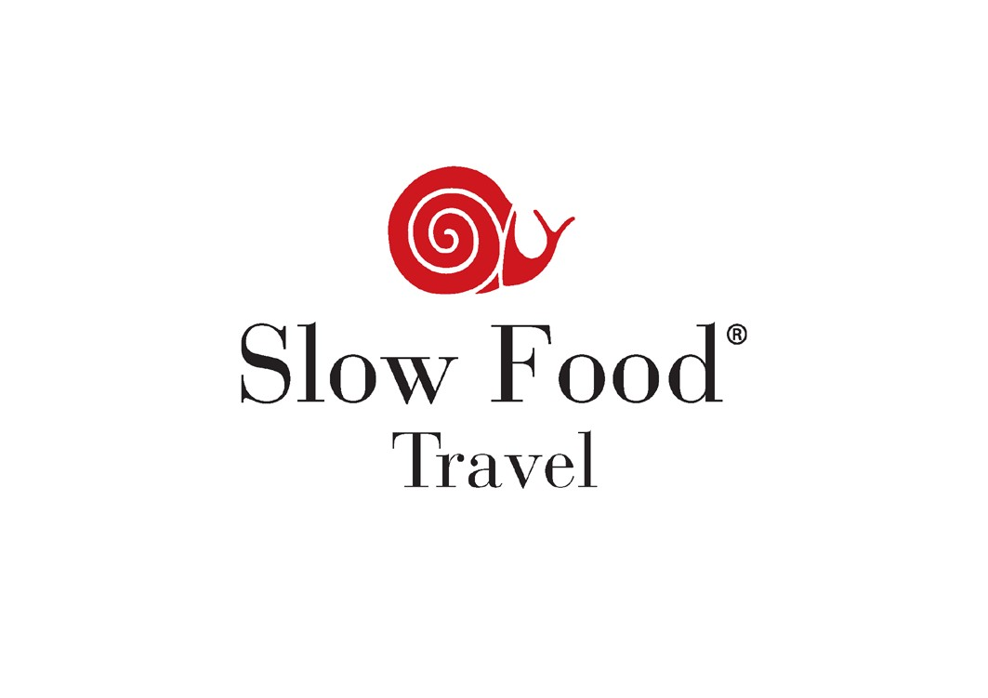

Handbook & Guidelines
Version 1.0 - June 2016

Editors:
Florian Sengstschmid, Barbara Van Melle, Artur Cisar-Erlach, Raffaella Ponzio, Ludovico Roccatello, Mariusz Rybak,

Translation and editing:
Carla Ranicki, John Irving, Gareth Newhouse

Layout and Graphics:
Artur Cisar-Erlach, Archivio Slow Food et al.

VERSION 1.0 5

INTRODUCTION 6

ABOUT SLOW FOOD 6

GIVE VALUE TO FOOD 6 PROMOTE THE RIGHT TO PLEASURE FOR ALL 7 EDUCATE FOR THE FUTURE 8 PROMOTE GASTRONOMIC CULTURE 8 PROMOTE BIODIVERSITY AND FAIR, SUSTAINABLE AGRICULTURE 8 THE VALUE OF BIODIVERSITY 8

ABOUT SLOW FOOD TRAVEL 10

MODEL AND OBJECTIVES 10

WHO IS INVOLVED AND HOW DOES IT WORK? 10

IN THE AGREEMENT THE SIGNING PARTIES AGREE TO: 12

INDIVIDUAL STAKEHOLDERS IN THE PROJECT PERFORM THE FOLLOWING FUNCTIONS: 13

THE MANAGEMENT COMMITTEE: 13 THE SLOW FOOD FOUNDATION FOR BIODIVERSITY: 14 SLOW FOOD INTERNATIONAL (THROUGH THE EXECUTIVE COMMITTEE): 15 THE SLOW FOOD CONVIVIA (OR OTHER LOCAL BODIES RECOGNIZED BY SLOW FOOD) AND SLOW FOOD INTERNATIONAL: 15

FOOD PRODUCTION CRITERIA 16

FOOD PRODUCTS ACCORDING TO SLOW FOOD 16

GENERAL CRITERIA FOR PRODUCTION CHAINS 18

SPECIFIC CRITERIA FOR PRODUCTION CHAINS 18

ANIMAL CHAIN 18 VEGETABLE CHAIN 22

HOSPITALITY CRITERIA 29

HOSPITALITY ACCORDING TO SLOW FOOD 29 GENERAL CRITERIA 30 SPECIFIC CRITERIA FOR CATERING 31 SPECIFIC CRITERIA FOR ACCOMMODATION 32 BREAKFAST 33

TRAINING FOR COOKS, FOOD PRODUCERS AND MANAGERS OF FACILITIES 36

TRAINING AND EXCHANGES AMONG SUPPORTERS OF THE PROJECT 36 PROMOTIONAL AND EDUCATIONAL ACTIVITIES FOR VISITORS 39
PROMOTION ACTIVITIES 39 LOCAL EVENTS 39 PRODUCT AND COOKING EXCHANGES 40 FARMERS’ MARKETS 40 INTERNATIONAL EVENTS 40 EDUCATIONAL EXPERIENCES 41 GASTRONOMIC EVENTS, FESTIVALS AND OTHER INITIATIVES 41

COMMUNICATION 42

INTERNATIONAL COMMUNICATION 42 LOCAL COMMUNICATION INITIATIVES 42

SPECIFICATION OF GUIDELINES ONLY FOR SLOW FOOD TRAVEL ALPE-ADRIA KÄRNTEN 43

OTHER REGION-SPECIFIC CRITERIA FOR PRODUCERS, HOTELS AND RESTAURANTS 43

HOSPITALITY CRITERIA 43

SPECIFIC CRITERIA FOR ACCOMMODATIONS 43

SPECIFIC, REGION-TYPICAL SLOW FOOD TRAVEL BREAKFAST FOR THE GAILTAL AND LESACHTAL REGION: 44

SPECIFIC CRITERIA FOR PRODUCTION CHAIN 45

MEAT, CURED MEATS AND MEAT BASED PRODUCTS 45 SPECIFIC CRITERIA FOR KNOWLEDGE TRANSFER TO THE CONSUMER 45
LOGO FOR PROJECT COMMUNICATION 46

LOGO FOR INDICATION - PRODUCERS AND HOSPITALITY FACILITIES 46

SLOW FOOD TRAVEL LOGO 46

LOGO TEMPLATE AND BRAND LICENSING RIGHTS FOR SLOW FOOD TRAVEL 47

THE “SLOW FOOD TRAVEL” TRADEMARK 47

LICENSING RIGHTS AND USAGE GUIDELINES 47

PRACTICAL USE 50

PROTECTION ZONE FOR THE TRADEMARK: 50

BACKGROUND TO THE TRADEMARK: 51

TRADEMARK PLACEMENT: 51

VERSION 1.0
This Slow Food Travel Handbook and the Guidelines within it are Version 1.0 and may be unilaterally changed by Slow Food International. Once issued, the updated version of the handbook takes immediate effect and is binding for all partners.

INTRODUCTION

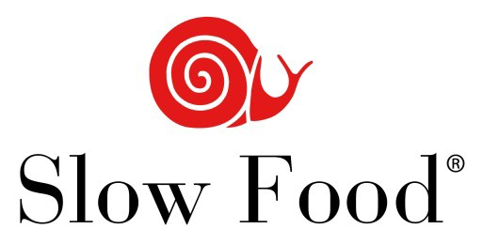ABOUT SLOW FOOD
Slow Food is an international non-profit association that works in 150 countries, committed to restoring the proper value to food, with respect for producers who work in harmony with the environment and ecosystems, using skills preserved by local areas and traditions.
SLOW FOOD IS SUPPORTED BY A CLOSE- KNIT NETWORK OF MEMBERS, FRIENDS AND SUPPORTERS THROUGHOUT THE WORLD, THROUGH WHICH IT PLEDGES TO:

GIVE VALUE TO FOOD
The most common food production and consumption systems today are harmful to the Earth, to its ecosystems and to the peoples who inhabit it.
Taste, biodiversity, human and animal health, well-being and nature are coming under continuous attack. This jeopardizes the very urge to eat and produce food as gastronomes and to exercise the right to pleasure without harming the existence of others or the environmental equilibria of the planet we live on.
Each of us – consumers and producers – is called upon to practice and disseminate a new, more precise and, at the same time, broader concept of food quality based on three basic, interconnected prerequisites.

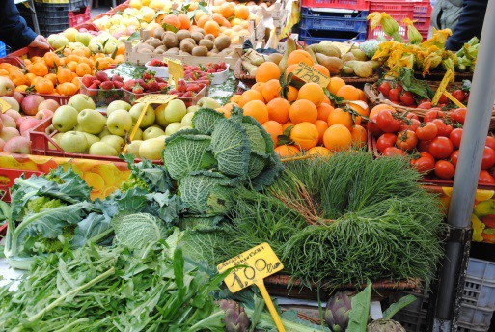QUALITY FOOD MUST BE:
©Claudia Saglietti

- Good
A food’s flavor and aroma, recognizable to educated, well- trained senses, is the fruit of the skill of the producer and of the choice of raw materials and production methods, which should in no way alter its naturalness.
- Clean
The environment has to be respected and sustainable practices of farming, animal husbandry, processing, marketing and consumption should be taken into serious consideration. Every stage in the agro-industrial production chain, consumption included, should protect ecosystems and biodiversity, safeguarding the health of the consumer and the producer.
- Fair
Social justice should be pursued through the creation of labor conditions that are respectful of man and his rights, and capable of generating adequate rewards; through the pursuit of balanced global economies; through the practice of sympathy and solidarity; through respect for cultural diversity and traditions.

Food must no longer be considered a commodity and a source of profit, but a way of respecting producers and the environment, and asserting the pleasure of taste.
Good, Clean and Fair quality is a pledge for a better future, an act of civilization and a tool to improve the food system as it is today.

PROMOTE THE RIGHT TO PLEASURE FOR ALL
With events encouraging meetings, dialogue and the joy of being together. Because giving the right value to food also means giving the right importance to pleasure, learning to enjoy the diversity of recipes, flavors and gastronomic cultures, recognizing the variety of places where food is produced and artisan production techniques are practiced, and respecting the rhythm of the seasons.

EDUCATE FOR THE FUTURE
©Paolo Andrea Montanaro
Knowledge of the food we take home can help the planet. That’s why Slow Food involves schools and families in educational and fun activities, including School Gardens and the “10,000 Gardens in Africa” project.

PROMOTE GASTRONOMIC CULTURE
To go beyond recipes alone, because food is much more than nourishment; behind it are producers, local areas, emotions and pleasure.

PROMOTE | BIODIVERSITY | AND | FAIR,
SUSTAINABLE | AGRICULTURE
To give value to small-scale agriculture and food artisans through the Slow Food Presidia project, and to catalogue and communicate traditional food products at risk of extinction with the Ark of Taste project. To develop new markets and new awareness through the Earth Market project and the organization of short courses.

THE VALUE OF BIODIVERSITY
From the outset, Slow Food has centered its strategies on the defense of biodiversity.
Biodiversity is life itself and the diversity of life at various levels, from the smallest and most elementary (genes, the building blocks of life), to animal and plant species, to more complex levels (ecosystems). These levels intersect, influence each other and evolve.
In the history of the Earth, everything has an origin and an end and, in every era, many species have gone extinct, but never at the amazing rate of the last few years, a thousand times faster than in previous eras. And for the first time ever the culprit is man, who continues to destroy rainforests, to overbuild, to pollute water and land with pesticides and chemical fertilizers, and to accumulate plastic in seas and oceans. And who insists on marginalizing the last stewards of the earth: small farmers, shepherds and fishers, who know and respect the extremely fragile balance of nature.
In addition to wild plants and animals, breeds domesticated by man and dairy and meat breeds selected by man are also disappearing.

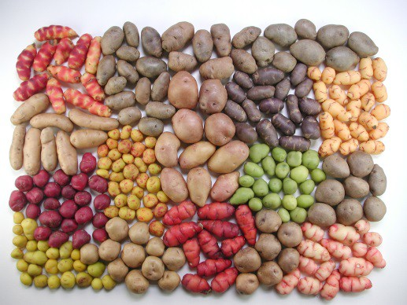According to the FAO, 75% of plant varieties have been lost for good. In the United States, the figure reaches 95%. Today, 60% of the world’s food is based on three cereals: grain, rice and corn. Not the thousands of rice varieties selected by farmers that used to be cultivated in India and China, or the thousands of varieties of corn that used to be cultivated in Mexico, but a very small number of hybrids selected and sold to farmers by multinational corporations. This is why Slow Food is developing projects to protect biodiversity all over the world. To preserve this wealth, it has created the Ark of Taste, in which it is gathering — before they disappear — plant and animal species and processed foods (breads, cheeses, cured meats) that are part of the culture, history and traditions of the world’s communities. While the Ark of Taste is a catalog of food products, Slow Food has also launched a project — the Presidia — that involves producers directly. The Presidia work specifically to safeguard traditional food products (Ark Products), traditional techniques (of fishing, livestock breeding, food processing, plant cultivation), rural landscapes or ecosystems. Another important tool for preserving, disseminating and promoting biodiversity is Slow Food gardens: family, community and school gardens. To bring small producers and consumers together, Slow Food also promotes Earth Markets all over the world.
©Archivio Slow Food

ABOUT SLOW FOOD TRAVEL

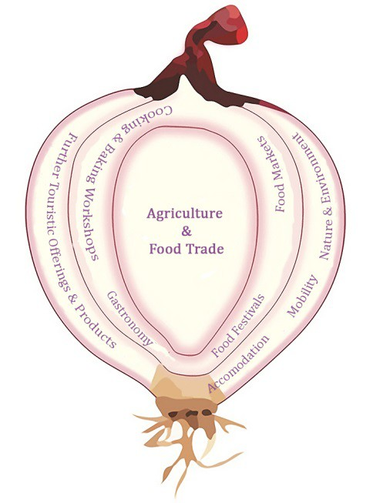MODEL AND OBJECTIVES
Meeting people and exchange have always acted as a spur to travel. The excitement and pleasure of traveling come from living experiences, hearing new stories and meeting new people. Slow Food Travel is a Slow Food project whose aim is to develop and promote a travel experience that is in line with the Slow Food philosophy. The Slow Food Travel project consists of different components that can be represented graphically as an onion.
At the center of the project are food and food production. Unique and biodiverse gastronomic identities constitute the heart of the project and underpin all its activities, interlinking the various attractions at the outer layers. The latter include osterias, agriturismi, restaurants, inns, bars and leisure venues, and connected activities such as fairs, events and food and wine tastings. The result is a convivial community that interacts and works as a system, welcoming visitors who discover it through food. The project seeks to develop tourist itineraries and services through the promotion of local cultural, agri-food and gastronomic biodiversity, thanks to the participation of visitors (visits to food companies and farms, tastings, events and so on). Its ultimate goal is to educate and raise awareness among visitors about the conservation of biodiversity and cultural heritage, identities and local gastronomy, as well as to develop connections between virtuous businesses in different locations in order to spread a more sustainable model of tourism.

WHO IS INVOLVED AND HOW DOES IT WORK?
Slow Food Travel is a project of Slow Food International and its appointed entities. As a matter of course, it involves the involvement of one or more Slow Food Convivia (or other local bodies recognized by Slow Food) in the local area. Slow Food International reserves the right to approve or refuse initiation of the project on a case-by-case basis, as well as use of the logo which has to be used as defined by its code of use.

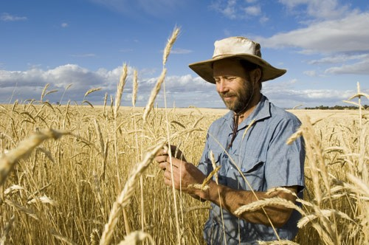Moreover, in order to develop the project, as well as actively involving local producers and hospitality operators, it is strongly recommended to involve:
©Archivio Slow Food

- The local tourism organization and its public and private stakeholders;
- Local institutions;

These entities play a crucial role to promote the project within the area and beyond, through assistance, support and communication. In developing the project, the Convivium must involve actors in the local area to ensure participatory management. Membership of the local Slow Food Convivium (or other local bodies recognized by Slow Food) and adherence to the guidelines are required of all the local producers, hospitality operators and other participants involved in the project.
The Convivium – preferably in cooperation with the local tourism organization – therefore sets up a management committee whose members, besides the representatives of the Convivium (or another local body recognized by Slow Food), should include the following representatives:

- Local institutions (in particular the local tourism organization and/or those responsible for tourist/cultural activities);
- Food producers, restaurateurs, hoteliers, etc. in the local area;
- Civil society entities interested in the project (social and cultural associations, other bodies etc.).

Slow Food International, or a legal entity authorized by Slow Food International, signs the agreement directly with the local management committee.

IN THE AGREEMENT THE SIGNING PARTIES AGREE TO:

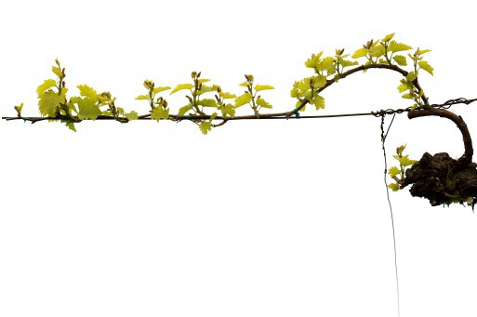
©Franciacorta
- Respect the goals, vision and the philosophy of the project;
- Respect the criteria set out in the project dossier;
- Respect the instructions set out for use of the Slow Food Travel logo (attached Code of Use and Addendum).
- Respect the Regional Specific criteria of every Slow Food travel destination. (attached Regional Specific Criteria Addendum)

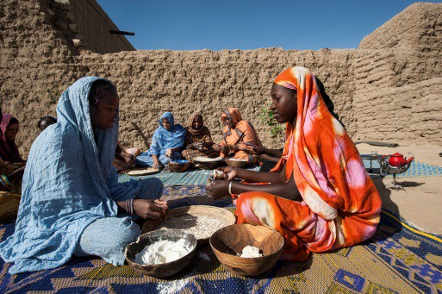INDIVIDUAL STAKEHOLDERS IN THE PROJECT PERFORM THE FOLLOWING FUNCTIONS:
©Paola Viesi
THE MANAGEMENT COMMITTEE:

Signs the agreement with Slow Food International (or a legal entity authorized by Slow Food International);
- Assumes responsibility for ensuring the implementation of and compliance with the agreement;
- Draws up any necessary addenda to the guidelines in order to propose supplements or adaptations that contextualize guidelines with measures appropriate to the specific nature of the local area in question;
- Maps the area interested in the project in order to identify subjects to involve producers, hospitality operators or civil society;
- Selects producers and hospitality operators that join the project and is responsible for allowing them to use the logo or not (respecting the contextualized guidelines addenda);
- Gathers data about producers and hospitality operators through special questionnaires (provided by Slow Food International) and visits thereto;
- Develops experience tour packages;
- Produces written presentations of supporters;
- Organizes local events and initiatives;
- Organizes fundraising activities at local level;
- Promotes communication activities at local level in collaboration with Slow Food International and its appointed offices and entities;
- Pays contributions for inspection and consultancy activities;
- Manages relations with those responsible for product development and distribution of tour packages;
- Organizes a meeting at least once per year bringing together stakeholders for training and evaluation of the project’s status.

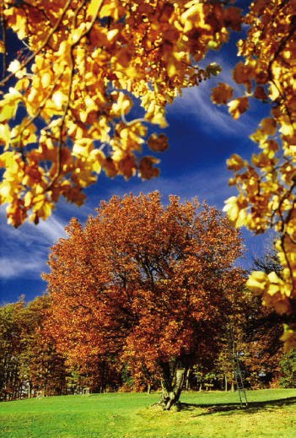THE SLOW FOOD FOUNDATION FOR
©Archivio Slow Food
BIODIVERSITY:

- Supervises the process for selection of producers and hospitality operators by the management committee and the information gathered (e.g. reading and assessing questionnaires, any necessary addenda, liaising with any other projects already active in the local area, such as Slow Food Presidia, Earth Markets, Slow Food Planet and so on) in order to provide the final technical evaluation of admissibility to each project;
- Manages the international online database (also editing supporters’ contributions to the website) that forms the official catalogue of Slow Food Travel territories;
- Manages international communication (site, social media, general communication material, press coverage, etc.);
- Coordinates exchange initiatives and any international events organized by the Slow Food association;
- Trains people to work on the project and on material for the launch of the project;
- Performs inspection activities.

IT MAY ALSO:

- Visit businesses indicated by the management committee to verify their compliance with the rules established by the project;
- Develop training activities and workshops in line with the needs of the local area in question;
- Provide consultancy.

SLOW FOOD INTERNATIONAL (THROUGH THE
EXECUTIVE COMMITTEE):

- Approves and signs draft agreements, thus making official a local area’s inclusion in the Slow Food Travel project;
- Disseminates and promotes the project across its network;
- Takes final decisions with regard to any unsolvable situations of conflict that may arise at local level and to national (or regional) situations outside the channels established at international level.
THE SLOW FOOD CONVIVIA (OR OTHER LOCAL BODIES RECOGNIZED BY SLOW FOOD) AND SLOW FOOD INTERNATIONAL:

- Have the right to revoke permission (according to the Code of Use) to use the logo and name of Slow Food Travel, when the project does not respect international or local criteria and when it is considered not to be in line with the goals, vision and philosophy of the association. This decision must be supported by a written communication explaining the reasons for the decision, sent to Slow Food International and the Foundation for Biodiversity.

FOOD PRODUCTION CRITERIA
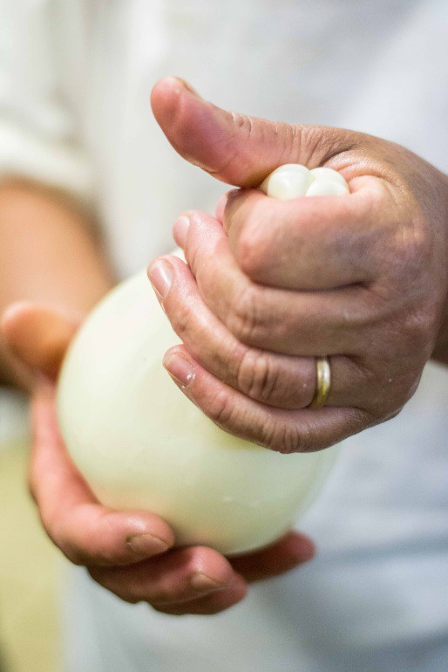This chapter presents the criteria to be used for the selection of producers and products to be included in the Slow Food Travel project.
©Archivio Slow Food

FOOD PRODUCTS ACCORDING TO SLOW FOOD
The project will take into consideration foods that are traditional, typical and artisanal, as defined below.

“Traditional” - means foods linked to the memory and identity of the community involved in the project. They could be varieties, ecotypes, breeds or animal populations, either indigenous or fully acclimatized to a specific area over the medium or long term (at least 70 years), or food products (e.g. cheeses, cured meats, sweets, breads, preserves, etc.) of vegetable or animal origin.
- “Typical” - means a food that is not necessarily native to the area involved in the project, or which has acclimatized to the area over time, but whose production or cultivation has been practiced for a long time and to such an extent that it characterizes the context in which it is cultivated or produced.
- “Artisanal” - means the producer must oversee all the production phases, applying skill and dexterity (passed down through their family or learned from other local artisans). This body of knowledge ensures that the products have a specific, unique identity and are easily distinguished from others produced using industrial and standardized models and practices. The artisan does not necessarily have to be personally responsible for all of the production phases (they can have a workshop with employees) but it is important that they are a constant presence on the premises, coordinating the work of any other family members or employees, who learn the traditional skills from them.

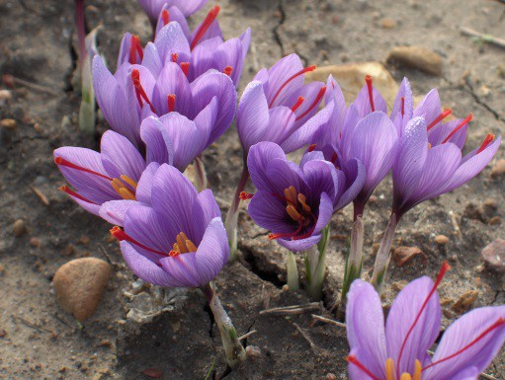The foods promoted by the Slow Food Travel project come from local production chains, in other words using ingredients that are grown or raised in the local area of the project, which gives them a specific identity.
©Chiara Meloni
The Slow Food Travel project focuses attention on the significant food products of a local area that have a real or potential possibility for promotion, that represent a historic tradition or a particular social and environmental value and that are of recognized quality.
Products that are involved in Slow Food projects such as Ark of Taste, Presidia, Earth Market, Food Communities, represent productions that follow these principles and should be promoted within the Slow Food Travel network.

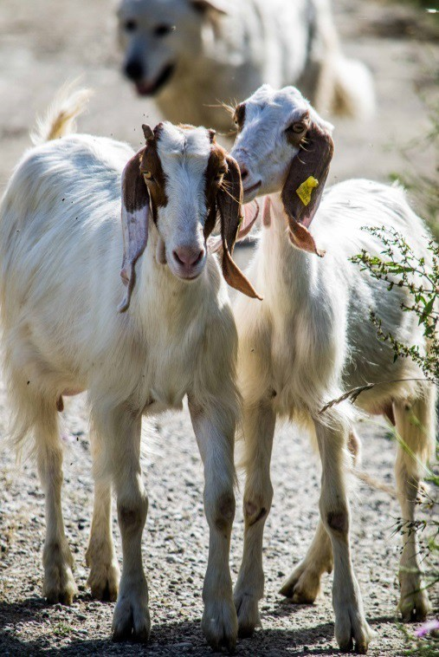GENERAL CRITERIA FOR PRODUCTION CHAINS
©Archivio Slow Food
Production chains must be based on agro-ecological practices, in other words practices whose objectives include safeguarding and promoting local biodiversity, protecting soil fertility and defending the landscape.
Additionally, with regard to foods of animal origin (including food products), the animals must be reared using extensive practices that protect their welfare.
The use of synthetic chemicals (fertilizers and pesticides) for cultivation or antibiotics in animal farming is not allowed.
The use of GMOs is not allowed in animal feed or as ingredients in food products.
Synthetic additives, preservatives or colorings cannot be used during the production process.
Producers must commit to reducing waste along the whole production chain, also avoiding the use of superfluous packaging made from non- biodegradable materials and single-use containers.
Any exceptions to these rules can only be granted in specific cases, for good reason and when backed up by detailed explanations.

SPECIFIC CRITERIA FOR PRODUCTION CHAINS
ANIMAL CHAIN

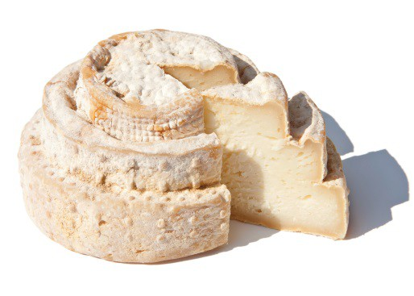CHEESE, MILK AND OTHER DAIRY PRODUCTS
Dairy products must be obtained from farming methods that respect animal welfare (as established by the general animal welfare guidelines). The animals must be fed a varied diet, with as much fresh forage or hay as possible. Wherever possible, and for as long as possible, the animals should be grazed outdoors.
Dairy products must be made using milk processed directly in the farm’s facilities or supplied by local farmers to local dairies.
Cheeses must be made using raw milk. Heat treatment and pasteurization are not allowed. Exceptions to this rule are only allowed where there are legal restrictions.

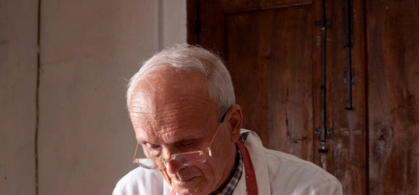
MEAT,
CURED
MEATS
AND
MEAT-BASED
Page | 19

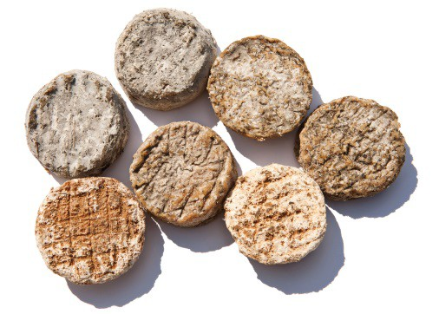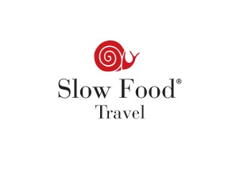When rennet is used, it must be exclusively of plant or animal origin. No type of synthetic preservative, additive or coloring can be used.
In the case of cheeses, the rind cannot be treated with any substances (e.g. anti-mold or anti-mite agents, paraffin, etc.) other than those used traditionally (when the rind is washed or rubbed with brine, oil, vinegar, tomato, etc.).
Dairies that produce cheeses without using commercial starter cultures will be given preference in selection.
Similarly, producers who use local breeds, who work in traditional workshops or who age their cheeses in natural environments will be given preference in promotion.

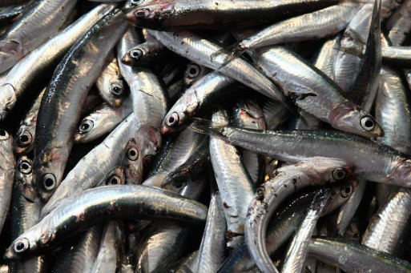FISH, SEAFOOD AND FISH-BASED PRODUCTS
Fresh or processed seafood has to be historically consumed and found in the area identified.
The animals must be caught using techniques that respect the ecosystem and are preferably traditional.
The fishing season must follow the development cycle for the species, avoiding any threats to its survival in the relevant area.
Fishing techniques aimed at catching specific species must be highly selective, reducing the chance of by-catch to a minimum.
In the case of aquaculture, the farming technique must also be respectful of the ecosystem, particularly with regard to feed, animal welfare, health treatments and waste management. The farmed species should preferably be characteristic of the local area.
For fish- and seafood-based food products, the use of any kind of synthetic preservative, additive or coloring (with the exception of salt,
  - NaCl) is not allowed. Smoke flavoring is not allowed, nor are preserves containing generically listed vegetable oils.

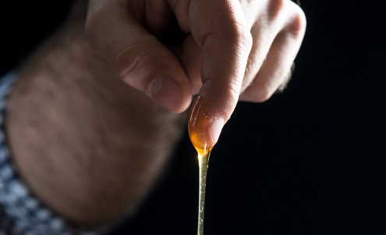
honey that has been heated to slow crystallization and honey with
Page | 20

PRODUCTS
Meat must come from farms that respect animal welfare (as established by the attached animal welfare guidelines). The animals must be fed a varied diet, with as much fresh forage or hay as possible. Wherever possible, the animals should be grazed outdoors.
All cured meats and other meat products must be produced in-house, and each step of the production process must take place within the local area of reference (including rearing the animals).
Pigs must only be slaughtered once they have reached at least 12 months of age
The ingredients for curing meat must be natural and not synthetic, and must come from the production area of the cured meat, with the exception of those that are impossible to find locally (e.g. spices or salt, i.e. NaCl). The only preservatives allowed are E252 (potassium nitrate) and ascorbic acid.
Starters, sugars, milk whey, caseinates and flavor enhancers are not allowed.
The casing must be natural.

Smoking must be over wood (liquid smoke is not allowed).

Producers of meat or meat products who rear their animals in wild or semi-wild conditions, who graze their animals, who use local breeds and who age their meats in natural environments will be given preference in promotion.

HONEY
Beekeepers can only be recommended for honey they produce themselves.
Their production area must be at least 3 kilometers away from areas with environmental pollution or contamination that jeopardizes the honey’s chemical, physical or sensory characteristics.
It is important to indicate the honey’s plant(s) of origin.

Only whole virgin honey will be considered, so pasteurized honey,

added sugar are all excluded.

Only treatments using substances that have the minimum possible impact on the finished product and on the hive are allowed: essential oils (that contain thymol, menthol, eucalyptus) and organic acids (formic acid, lactic acid, oxalic acid).
Honey can only be displayed and sold when it comes from hives where antibiotics, medicines or insecticides are used only to combat or prevent emergency situations.
Honey from hives where the bees are given protein-rich foods such as soy or powdered milk cannot be displayed and sold.
Honey characterized by the typical plants of the production area, or the areas where nomadic beekeeping is practiced will be given preference in promotion.
Any other hive products must respect the same rules as for honey. Honey from local bee breeds will be given preference.

EGGS
With regard to eggs, it is important that they are produced in a small- scale farming setting that is respectful of animal welfare and even better if they are organic (EU category 0).

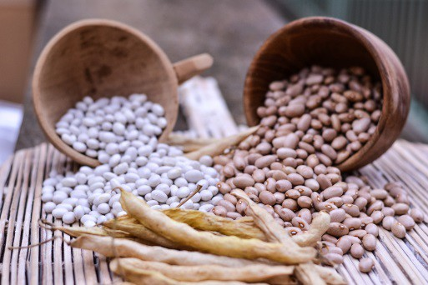VEGETABLE CHAIN
©IFederica Bolla

GRAINS, LEGUMES, FRUIT AND OTHER VEGETABLES
Cultivation should be based as far as possible on agro-ecological practices (as established in the general criteria).
The soil should be fertilized primarily with manure or organic fertilizers and the farmer should carry out agronomical activities aimed at preserving soil fertility (e.g. green manure, mulching, etc., depending on the context).
Weeds and other problems must be controlled primarily by using mechanical interventions. Products used to protect the plants must have a low environmental impact and must be used in compliance with the methods, timings and quantities indicated by the regulations for organic or integrated agriculture.
During the post-harvest phase, no chemical substances can be used to protect the produce. Only physical preservation methods can be used.

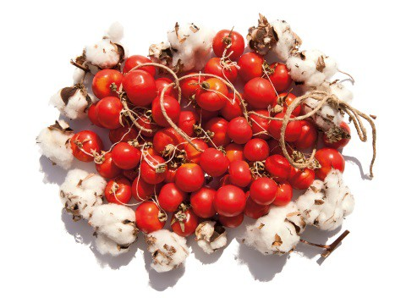VEGETABLE-BASED PRODUCTS AND PRESERVES

JAMS, MARMALADES, JUICES, VEGETABLES IN OIL, PICKLES, SYRUPS

Ingredients must be local (when possible).

The use of synthetic additives, such as artificial preservatives, sweeteners, thickeners, gelling agents, emulsifiers, stabilizers, colorings or flavorings is not allowed. The use of freeze-dried ingredients is also not allowed.
With regard to mushroom products, only producers of dried or oil- packed mushrooms that are picked or grown locally can be considered.
The use of palm oil and coconut oil is not allowed, and fruit and vegetable preserves containing generically listed vegetable oils can also not be admitted.
Natural flavorings must be herbs, spices, essential oils and/or extracts of the above. The label must specify the ingredient used (e.g. sage, garlic, cinnamon, etc.) rather than the generic phrase “natural

flavors”.

The minimum percentage of fruit in jams and marmalades is 65%. The minimum percentage of vegetables in vegetable preserves is 65%. Products with reduced sugar will be given preference.

VEGETABLE OILS

Only oils extracted from botanical species characteristic of the local area (olive, walnut, hazelnut, almond, etc.) will be considered.
Only producers who process their own-grown products (or supplied by other small-scale growers from the local area) in their own facilities or in a local mill will be considered.
In the case of oils whose fruits are subject to rapid deterioration, cultivation must take place within 50 kilometers of the milling location.
Harvesting must be directly from the tree, by hand or using non- damaging mechanical means. Harvesting from the ground, the use of permanent nets or the use of products to stimulate fruit drop are not allowed. The extraction procedure must be traditional to the local area and use only physical methods.
Olive oils must be extra-virgin.

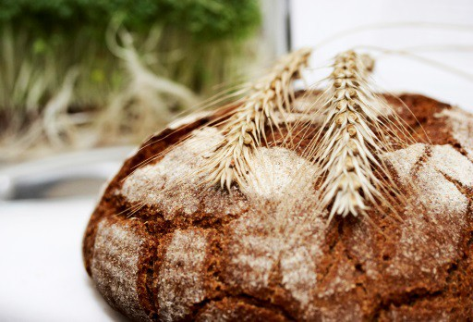BAKED GOODS AND SWEETS
©Archivio Slow Food

BREADS, FLOURS GRAINS, SWEETS AND COOKIES

The grains used to mill flour should preferably be locally produced, and the mill should also be locally based.
Whole-meal flours should be made from the whole grain, not from white flour with the addition of bran.
All bread must use natural leavening, the indirect method or a sourdough starter; some brewer’s yeast may be used as a starter.
The use of improvers, processing additives and other additives, such as stabilizers, preservatives, flavor enhancers, malted flours and malt extract, enzymatic aids, lecithin and emulsifiers, colorings, polishers, waxes and artificial flavors is not allowed.
Natural flavorings must be herbs, spices, essential oils and/or extracts of the above. The label must specify the ingredient used (sage, rosemary, garlic, cumin, fennel seeds, etc.) rather than the generic phrase “natural flavors”.
The use of frozen uncooked or partially cooked dough or of any industrial semi-finished product is not allowed.
For sweets, the use of any industrial semi-finished product, such as pastry mixes, margarine and hydrogenated fats, oils obtained using solvents and refined or emulsified lards is not allowed. The use of pure lard, without any chemical manipulation, is allowed.
Products containing margarine, palm oil, coconut oil, refined or emulsified lard or other surrogates for ingredients of higher quality (for example, olive pomace oil instead of olive oil) cannot be displayed and sold.
Ingredients other than flour (fruit, nuts, berries, seeds, candied fruit, etc.) must be local (when they can be sourced from the area).
The minimum standard for eggs is free-range (EU category 1) Preference will be given to organic eggs (EU category 0).
Baked goods and sweets containing freeze-dried or frozen eggs cannot be displayed and sold.

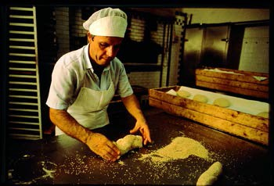The finished product must be preserved without the use of chemicals.
©Fabio Artusi

With regard to bread, baked goods and sweets, priority will be given to those made following traditional recipes.
Similarly, products made using native grains or ancient grain varieties will be given preference in promotion, as will bakeries that use wood- fired ovens.

PASTA
©Marco Del Comune & Oliver Migliore

DRIED PASTA

Only dried pasta made entirely in the workshop of the recommended producer and using flour from grains whose origin is known and indicated will be considered.
The minimum standard for any eggs used is free-range (EU category 1).
The use of synthetic preservatives and other additives is not allowed. Drying should be slow, at low temperatures and static.
Dry durum wheat pasta should be bronze extruded.

Dried pasta produced with grains of local origin or ancient varieties and pasta shapes linked to local tradition will be given preference.
Priority will go to companies that are responsible for the whole production chain, from grain cultivation to pasta production, and those that use organic eggs (EU category 0).

FRESH AND FILLED PASTA

The additional rules for fillings are as follows:

The minimum standard for eggs is the same as for pasta.

Freeze-dried or frozen eggs, preservatives and artificial additives such as stabilizers, flavor enhancers, aids, lecithin and emulsifiers and colorings cannot be used.
Natural flavorings must be herbs, spices, essential oils and/or extracts of the above. The label must specify the ingredient used (e.g. sage, rosemary, garlic, chili, etc.) rather than the generic phrase “natural flavors”.
For the filling ingredients (cheese, vegetables or meat) reference must be made to the specific criteria for these categories, and they must be of local provenance (when they can be sourced from the area involved in the project).

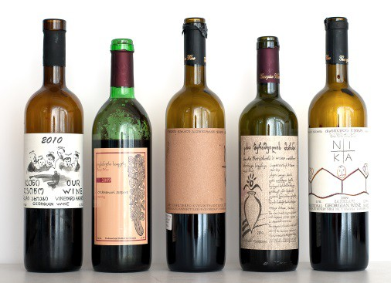WINE, BEER AND SPIRITS

WINE

©Archivio Slow Food
Only producers that make wine from grapes they have grown themselves will be considered.
Vineyard cultivation must be based on agro-ecological practices (as established by the general criteria).
The use of native grape varieties will be preferred.

Only physical techniques can be used during wine-making; only the use of limited quantities of sulfur dioxide is allowed.
Products that do not use selected commercial yeasts will be given preference in promotion

BEER

Only producers who make beer from individual ingredients will be included in the project. The use of semi-prepared mixes is not allowed.
The beer must be unpasteurized and must not use synthetic preservatives or microfiltration.
The ingredients must be local (when they can be sourced from the area).
Beers that use local or ancient varieties and those produced according to historic local styles will be given preference in promotion.

OTHER ALCOHOLIC BEVERAGES

Only spirits made from local plants (e.g. herbs, berries, roots, etc.), cultivated according to agro-ecological techniques or, if wild, from harvesting systems that do not cause biological damage to the species can be recommended.
The recommended spirits should preferably be made following traditional local recipes.
Synthetic colorings, preservatives and other additives are not allowed.

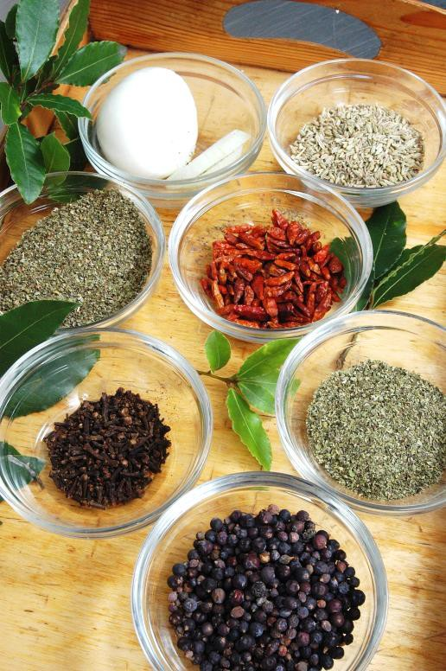VINEGAR
©Franco Tanel
Only vinegars made with local ingredients, preferably produced in- house, whose cultivation respects agro-ecological criteria, can be recommended. In the case of wine vinegars, those made from local grape varieties will be given preference in promotion.
Only vinegars aged artisanally in barrels and acidified using mother of vinegar can be selected.

HERBS AND WILD PLANTS
For wild products, such as certain herbs and roots, it is necessary to respect the harvesting periods during which biological damage is not done to the species. Harvesting systems must not cause damage to the species and the quantities harvested must be within the limits set by the laws in force.

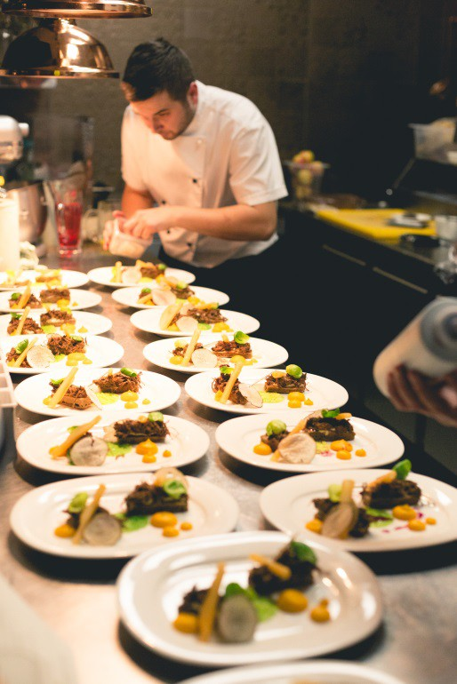HOSPITALITY CRITERIA
©Konrad Syag
The project seeks to identify hospitality facilities in areas involved in the Slow Food Travel project that are prepared or keen to provide hospitality according to the Slow Food philosophy.

HOSPITALITY ACCORDING TO SLOW FOOD
The grassroots organizational unit of the Slow Food movement is known as a Convivium, a name that conjures up banqueting and sitting round a dining table, not only to share food but also to converse and meditate and enjoy the pleasure of social interaction, the highest, noblest characteristic of food culture consolidated over time. Social interaction, the exchange of ideas and experiences, friendly fun and even business agreements are all part and parcel of the sharing of food.
Slow Food has summed up its vision of food, food production and food consumption in three principles: good, clean and fair.
Applying these three principles to hospitality facilities means identifying and signaling accommodation facilities that not only offer “the culture of hospitality, the pleasure of simplicity and courtesy, attention to identity, local culture and biodiversity to provide the highest quality always.” They must be places either restored with respect for the pre-existing structures or, if built recently, fit harmoniously into the landscape, adopting systems designed to save energy, using natural materials, protecting greenery and fertile soil, and reducing the impact on the environment.
Alongside the three founding principles outlined above, Slow Food Travel also continues to adopt the approach to hospitality which Slow Food has developed in its many publishing projects identifying tourist venues and itineraries all over the world, based on the discovery of traditional cuisines and a preferential relationship with food producers and exponents of artisan skills, and through the many events organized by its world network.
At the root of Slow Food’s approach is the old, but still current, meaning of hospitality in a broad sense: being in tune with local people in a given place — appreciating above all their cooking and convivial traditions — receiving a warm welcome in pleasant, well-

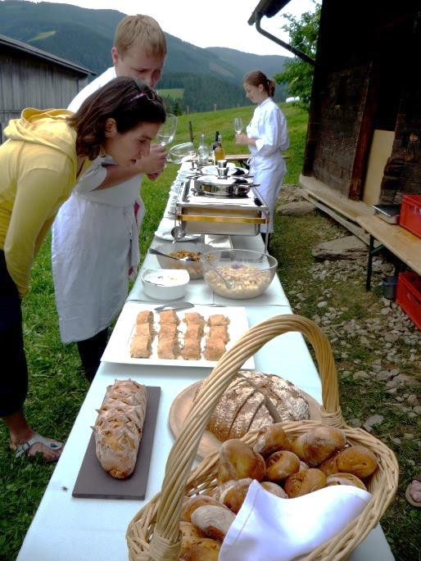organized places, opening out to others, the pleasure of other cultures and identities, discussion and exchange between visitors and visited places.
©Archivio Slow Food

GENERAL CRITERIA
The venues to be involved are ones that practice any form of catering and hospitality, hence: restaurants, osterias, bistros, cafés, mountain refuges, hotels, boarding houses, B & Bs, agriturismi and so on.
WHAT IS NECESSARY, ABOVE ALL, IS THE WILLINGNESS OF THE MANAGERS OF THESE ESTABLISHMENTS TO:

- Actively promote and offer a good information service about
the local area, its food products and food producers prepared to receive visits by networking with the producers themselves and local hospitality bodies and the whole Slow Food Travel network;
- Offer artisan products of local origin as opposed to mass- produced products (e.g. avoiding commercial confectionery
and soft drinks), and preferring those produced with
environmentally-friendly
practices;
agricultural
and production
- Avoid food and energy waste;
- Be prepared to undertake training activities to improve the overall tourist offer of their establishments to bring them closer and closer to the Slow Food philosophy;
- Spread awareness of the need to make sustainable consumer choices;
- Disseminate the Slow Food campaigns and philosophy.

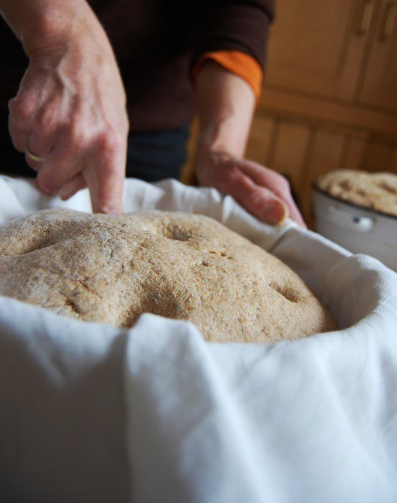SPECIFIC CRITERIA FOR CATERING
©Archivio Slow Food
AS FAR AS CATERING IS CONCERNED, IT IS ESSENTIAL TO FOLLOW THE SLOW FOOD APPROACH TO FOOD THROUGH PRACTICES SUCH AS:

Promoting products characteristic of local biodiversity and, more specifically and where applicable, those promoted by Slow Food projects such as the Presidia, the Ark of Taste, the Earth Markets, Food Communities and, in general, all local products that are “good, clean and fair,” as far as possible, in line with the criteria for food products;
    - Encouraging and strengthening direct relations with local producers, not only buying as much local produce as possible, but also organizing presentations of products in their establishments;
    - Respecting seasonality in meal preparation;
    - Cooking with fresh produce and avoiding frozen food, wherever possible;
    - Favoring the purchase of local meats from livestock farms that respect animal welfare;
    - Choosing sustainable and, if possible, local fish, avoiding in particular fish from conventional aquaculture;
    - Avoiding, as far as possible, industrial or semi-finished products, preservatives, thickeners and flavorings, using natural products in their place;
    - Using natural water whenever possible, avoiding in particular mineral waters from distant sources;
    - Serving as many raw milk cheeses as possible on their cheese trolleys;
    - Cooking the produce of small local farms and food workshops and telling guests about the latter in order to spread knowledge about them (for example, adding to the menu and any other forms of communication on their premises details of producers from whom they source their ingredients and information about their products;
    - Promoting gastronomic culture through the use of the most

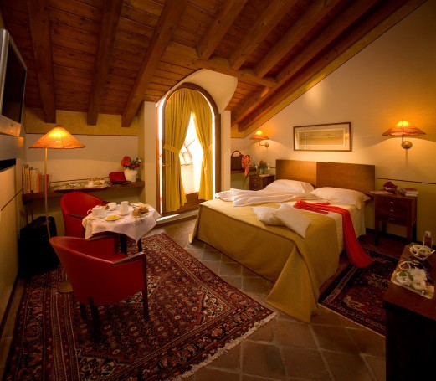
©Fiorenzo Calosso
characteristic food products from the local area, more specifically its traditional recipes;
- Presenting a well-designed wine list, not necessarily exhaustive but with a good range of local wines and spirits, craft beers, and the option to buy wine by the glass;
- Promoting traditional dishes;
- Tackling food waste by using leftovers or offcuts (adopting a nose-to-tail approach) and providing a doggy-bag service.

SPECIFIC CRITERIA FOR ACCOMMODATION
Accommodation facilities play a crucial role in defining the tourist experience insofar as they act as a benchmark for visitors. Selection criteria thus take into consideration a number of different aspects.
AS FAR AS THE STRUCTURAL FEATURES OF FACILITIES ARE CONCERNED:

- The number of rooms in a facility must be limited (preferably to no more than 20) and it is necessary, as far as possible, to avoid involving large, anonymous or uncared-for facilities in which the staff have not received adequate professional training; likewise, it is better to avoid restaurants with large reception rooms and too many covers (the maximum should be about 60);
- Bed & Breakfasts and agriturismi should provide a service that is as continuous as possible (i.e. all year round without long periods of closure);
- The selection criteria for “historic residences” (villas, manors, castles and so on) should be not only the beauty of the building itself, but also the quality of its services and facilities (beds, bathrooms, etc.), a feature that should not always be taken for granted. Places where the original charm of the ambience is spoilt by pretentious restoration work and ostentatious luxury should be avoided;
- The tranquility, charm and safety of the surrounding environment (places situated on busy roads should be avoided) is, of course, important, and preference should be

given to establishments immersed in greenery.
- Minibar: attention shall also be given to the minibar, to be filled with products and goods following the recommendations / guidelines set out for the project.

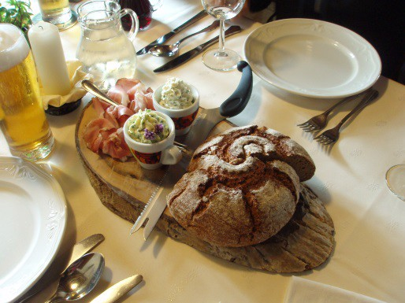BREAKFAST
©Archivio Slow Food
Breakfast is the meal that every visitor eats in a hospitality facility. It thus offers an important opportunity to present the local area and complete the hospitality offer.
On the subject of breakfast, it is important to include in the project only establishments that serve rich, varied meals composed mainly of homemade dishes that are fresh, seasonal, traditional and typical of the location, where possible with zero-mile ingredients. Establishments serving only or principally packaged foods should be avoided. When, for legal reasons, it is impossible to do otherwise, preference should be given to the most artisan, high-quality food products available on the market, avoiding those containing additives and artificial preservatives.
FOR EXAMPLE:

- Preference should be given to fruit juices produced with local fruit, craft-made locally where possible;
- Coffee and tea made with automatic machines and pods should be avoided and preference should be given to quality products, where possible sourced from small-scale coffee roasters and tea merchants or on the fair trade circuit;
- Whole cane sugar from the fair trade circuit should be served as an alternative to refined sugar as well as artisanal, local honey;
- Preference should be given to traditional, homemade pastries, brioches, biscuits, cereals and cakes, produced as far as possible with local cereal varieties, as opposed to commercial products;
- Breads should be artisanal, naturally leavened where possible, and commercial and packaged bread should be avoided at all costs;

- A range of fresh seasonal fruit (local varieties, wherever possible) should always be served and inappropriate fruit that has traveled long distances avoided;
- Yogurt, cheese and charcuterie should be chosen locally according to the criteria for the respective supply chains.

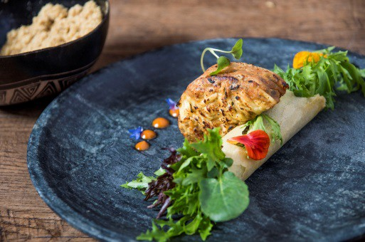Each Slow Food Travel destination is also recommended to define, in the course of its development, a characteristic breakfast for the area, including a list of products and suppliers. This breakfast will then become a significant part to be fulfilled by all participating accommodation facilities in the Slow Food Travel project and must be promoted by all partners. Specifically, the producers name and, if available, their story must be displayed next to the breakfast in order to have the desired marketing synergy effect.
©Lucas Terribili
For establishments that also serve food and drink, the specific criteria for catering apply.
IT IS IMPORTANT TO OFFER GUESTS OTHER SERVICES TO HELP MAKE THEIR STAY COMFORTABLE:

- Information about and agreements with local transport companies and facilities for vehicle hire, with special reference to alternative means to motor vehicles;
- Material and information about Slow Food Travel, other local tourism opportunities (guides, brochures, maps), Slow Food and its activities;
- Local newspapers and internet access;
- Where possible, play areas for children;
- Television sets in dining rooms and guest reception areas should be avoided;
- Contacts with the producers of ingredients that appear in dishes on the menu and the opportunity to organize visits to their premises.

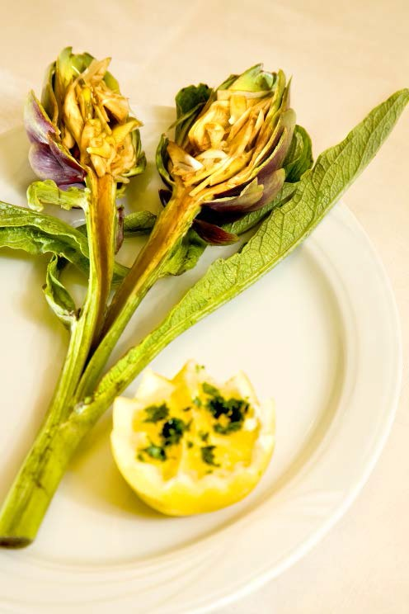RESPECT FOR THE ENVIRONMENT SHOULD TRANSLATE INTO DAILY MANAGEMENT ROUTINES THROUGH PRACTICES SUCH AS:
©Paolo Andrea Montanaro

- Waste recycling, including for guests;
- The use of biodegradable detergents (for people, linen, crockery and interiors) rather than conventional ones;
- Instructions for guests about correct and proper use of towels and paper;
- Use of recyclable materials such as paper and glass instead of plastic;
- Avoiding single portions and single-dose detergents as much as possible;
- Where possible, supplementing energy supplies with renewable energy systems (such as photovoltaic and solar panels, etc.).

TRAINING | FOR | COOKS, | FOOD
PRODUCERS | AND | MANAGERS | OF
FACILITIES

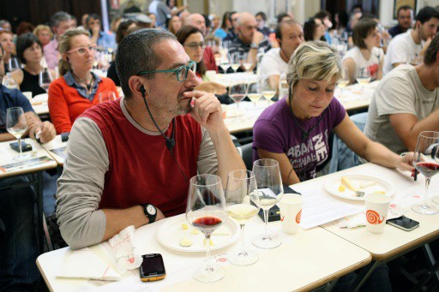TRAINING AND EXCHANGES AMONG SUPPORTERS OF THE PROJECT
The organization of continuous education as well as ongoing training activities for the people involved in the project are a fundamental part of the process.
Slow Food’s approach to education and training has always been set apart by its directness, so teaching by doing and learning by tasting, smelling, observing and growing. Through its Taste Workshops and subsequently its School Gardens — as well as the huge variety of learning activities during events and our publishing initiatives — Slow Food is now a reference point for education on the subjects of taste, the environment and agri-food.
Everything on Planet Earth is intertwined and it is impossible for us to understand anything about a living system — which is precisely what food is — if we do not study it with an interdisciplinary, complex, open approach.
The main content of educational actions is complexity and connections. For example, a course for honey-tasters is useless without a contextual explanation of the role of bees in agricultural production and the harm that is being caused to them by the use of synthetic chemicals.
Without education there is no consciousness of the value of food. And without the competence that ensues — i.e. the ability to recognize quality and value — the only choice criterion becomes price. It is here that the market-oriented industrial production model, which has the power to lower prices, prevails.
Education and training on sustainable food production must be acknowledged and promoted as an extra element of excellence and protection for a community’s cultural heritage.

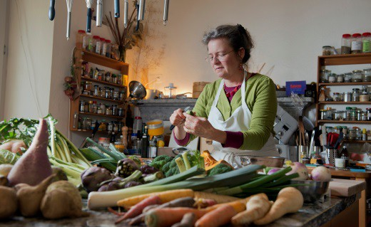MORE SPECIFICALLY, PEOPLE RESPONSIBLE FOR HOSPITALITY IN A COMMUNITY AND FOOD PRODUCERS IN A SLOW FOOD TRAVEL AREA MAY FOLLOW A COURSE THAT INCLUDES:
©Hans-Peter Siffert

Specific training on Slow Food topics and projects around the world to define the association’s approach to gastronomic culture;
    - The organization of meetings to get to know and present local food products, in which producers speak about themselves and enjoy the same role as the other trainers present, in which the sensory/tasting aspect is backed up by in-depth exploration of related production and environmental problems;
    - The organization of workshops in which producers, restaurateurs, cooks, hoteliers and other stakeholders in the local network build and create together the experiences that will constitute their area’s tourist offer;
    - The organization of tastings. Through comparative tastings of samples from different producers, it is possible to identify and eliminate any manufacturing or aging defects and to improve the sensory quality of products. Even without defects that need to be corrected, careful tasting can offer useful indications about sensory differences between producers, between areas, and new stimuli to learn to recognize an area and its products with true skill, and these differences can be communicated, conveyed and promoted. Slow Food producers and experts can take part in the tastings;
    - The interconnection, by Slow Food through its international network of technicians and experts, of producers and technicians all over the world to compare and solve production and organizational problems;
    - The organization of training seminars. The Slow Food Foundation for Biodiversity can organize training seminars for producers on the various supply chains (cheese, fruit and vegetables, meat and so on), both on-site and at its international headquarters, depending on availability;
    - Presentations and meetings with experts to enable operators

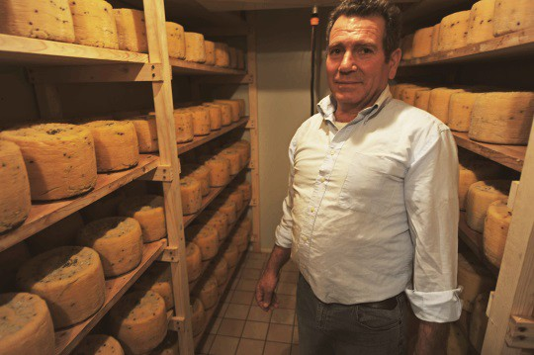
©Archivio Slow Food
to become, in turn, narrators of food products from their own local areas and the gastronomic, cultural and environmental context in which they live, and thus convey all this to their customers (it is unthinkable for restaurant managers not to know what is behind the local cheese or cured meat they serve to their customers, and that they are unable to explain the virtuous production model behind the ingredients of a dish);
- Each new member should be properly trained before officially joining the project;
- The organization of exchange trips between producers, restaurateurs and hospitality operators in different areas and countries. This is a fundamental opportunity for comparing experiences, enriching others and being enriched, finding new stimuli, creating synergies and helping to disseminate a new model of slow tourism, and finding solutions and forms of promotion and commercialization that can be replicated in one’s own local area.
- Attendance at Slow Food international events (such as Terra Madre) is strongly recommended to provide an excellent opportunity for both training and networking.

Slow Food Travel destinations agree and define the planned training and educational activities with Slow Food International (or its appointed entities) before starting the activities.

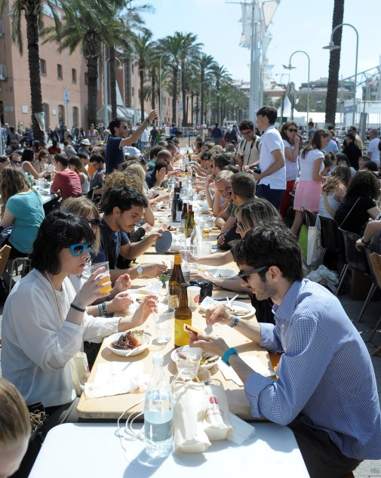PROMOTIONAL AND EDUCATIONAL ACTIVITIES FOR VISITORS
Specifically required, are activities for consumers that contribute to the awareness and the understanding of good, clean and fair food. The aim of these activities is to bring consumers and producers closer together and help turn consumers into co-producers. This may take the form of workshops, cooking classes, tastings, markets or similar events.
All communication activities, regardless of target audiences and locations, have to respect the legal framework for using the logo set out in the specific agreement, and have to follow the dedicated branding guidelines of the Slow Food Travel brand. These guidelines outline the proper use of the logo, its correct integration into all kinds of marketing material and offer some creative input on how various marketing collaterals published at the Slow Food Travel destination should look and feel.
All online and offline publications produced by the regional Slow Food Travel management committee or an authorized affiliated body, which carry the Slow Food Travel regional brand, have to be approved by Slow Food International, or a legal entity authorized by Slow Food International. The official catalog of Slow Food Travel territories and related participants are online at www.slowfoodfoundation.org

PROMOTION ACTIVITIES
The aim of all the many promotional and communication activities at local level must be to convey the importance of local food products and to bring visitors closer to food producers, describing the uniqueness of these products and involving them to the point that they become “co-producers.” Below are some examples of activities that might be developed to involve travelers in a Slow Food Travel area.

LOCAL EVENTS
Local events, such as feasts and festivals and historical or cultural pageants are a huge draw for visitors and, at the same time, for producers and business operators, who not only have an opportunity

to sell their products but also, and more importantly, to make them known to the public attending and to forge relationships with journalists, buyers, enthusiasts and other producers. Events are a showcase for the whole local area network as well as for its Slow Food Convivium, which is given the chance to present its projects and the results it has achieved in the field.

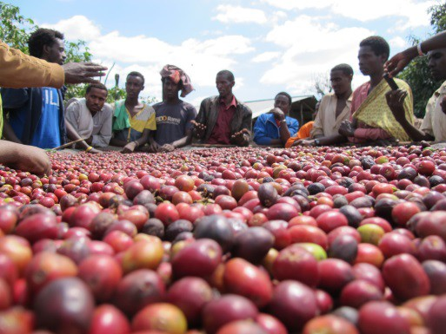PRODUCT AND COOKING EXCHANGES
©Michela Lenta
To visit new places is always to taste new flavors. Cooks are invaluable ambassadors, who can promote local food products and the philosophy of Slow Food. Cooks, restaurateurs and hoteliers can all create virtuous relations with local producers and farms by serving their produce and giving them visibility by informing customers about them.
At the same time, they can promote their work by arranging for them to meet customers and organizing interesting themed evenings and dinners to enhance knowledge of a given food product and the stories behind it.

FARMERS’ MARKETS
Local markets involving farmers and food artisans according to the criteria of the project represent important meeting places. Here, local producers present quality goods produced with eco-sustainable methods directly to consumers, at fair prices.
These events have a huge reach, especially in the high season, though they can also draw visitors in the low season. A Slow Food Travel area can also become an area that hosts and organizes an Earth Market (in this regard, please refer to the Earth Market guidelines).

INTERNATIONAL EVENTS
The participation of the Slow Food Travel areas in international events organized by Slow Food (Terra Madre/Salone del Gusto, Cheese, Slow Fish, etc.), as well as those organized nationally and regionally throughout the world, can provide a great visibility opportunity, a chance to open outwards to promote a local product and itineraries, sometimes in an international context, and to meet other protagonists of similar projects elsewhere in the world.

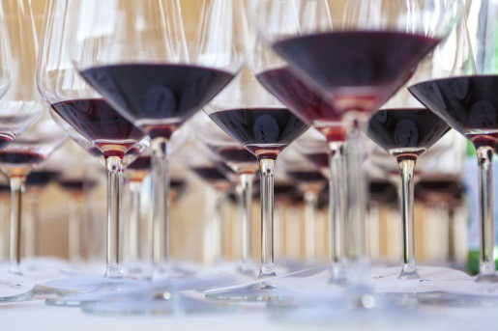EDUCATIONAL EXPERIENCES
©Kunal Chandra
Educational activities can play a central role in the tourist experience. They can take place in osterias, restaurants, inns and hotels, when they host presentations by cooks or food producers. They can also feature in events at which activities are organized for the public (from lectures to multi-sensory tasting courses). At the same time, events can provide an opportunity to involve visitors in the life of farms. Seeing plants and animals with one’s own eyes or trying to make a food product by oneself is an extremely significant experience.
In planning educational activities, special attention could be paid to their huge interest potential for children and families, who risk being cut out of other activities. Schools too can be involved in the discovery of Slow Food Travel areas as an alternative to the classic “day on the farm.”

GASTRONOMIC EVENTS, FESTIVALS AND OTHER INITIATIVES
We recommend collaboration with gastronomic events or festivals if, after careful evaluation, they are deemed to be in line with the objectives of the Slow Food Travel project (and the criteria set out).
Local events must be an important highlight of the project. They also provide an excellent chance to back up product promotion and consumption with activities such as short courses about local dishes and artisan food production.

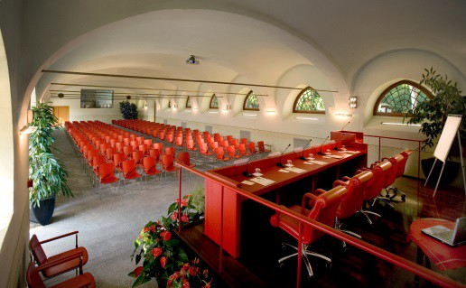COMMUNICATION
©Fiorenzo Calosso

INTERNATIONAL COMMUNICATION
The project will be identified internationally by a logo (attached), use of which is regulated by a series of guidelines (also attached).
The communication of the project internationally is managed in a special section of the Slow Food Foundation for Biodiversity international website, which presents the official local areas that are taking part in the project and businesses that are adhering to it.
Communication will also include the preparation of articles on the website and their dissemination via social media, newsletters and press coverage, plus, where proper funds are available, graphic, photographic and video material.

LOCAL COMMUNICATION INITIATIVES
Local communication initiatives may involve the opening of a website or blog dedicated to the specific local area and the creation of social media profiles (whose use has to be coordinated with international profiles). Websites and blogs will also be coordinated with Slow Food International websites and social media.
We also recommend the preparation and distribution of special, up- to-date press releases.
Maps, postcards and brochures are some examples of other materials that can be developed.
Communication must also include information about the themes and projects of the Slow Food association.
Each member of the project is required to communicate the whole project network (and not only individual activities) in order to strength the impact on the ground.
These activities will be supervised by the local management committee but must be approved by Slow Food International, or a legal entity authorized by Slow Food International, on a case-by-case basis.

SPECIFICATION OF GUIDELINES ONLY FOR
SLOW FOOD TRAVEL ALPE-ADRIA KÄRNTEN

OTHER REGION-SPECIFIC CRITERIA FOR
PRODUCERS, HOTELS AND RESTAURANTS

- Personal membership of business owners in Slow Food Alpe Adria Convivium in accordance with general Slow Food Membership criteria
- Knowledge of all Slow Food Travel components (training)
- Attend the local Slow Food Travel programs and actively participate in the training modules
- Participate in at least one educational workshop per year (Slow Food Convivium or ARGE)
- Communicate the Slow Food Travel program and its offers (presentation of advertising/promotional materials inside the establishment/business, as specified)
- Participation in the regional (Carinthia) program for qualification of quality “Kärntner Qualitätsgütesiegel für Beherbergung“ in gastronomy, for example.

HOSPITALITY CRITERIA
SPECIFIC CRITERIA FOR ACCOMMODATIONS

•
In the Slow Food Travel Destination Alpe-Adria Kärnten, the
specifications for accommodation are not defined by a maximum number of hotel rooms or restaurant seats, but that participating accommodation facilities should not be part of a hotel or restaurant chain. Restaurants should also not be self-
service only.

In addition to the criteria set by SFI, Slow Food Travel Alpe Adria Carinthia, has set additional, binding criterion regarding a typical, regional breakfast.

SPECIFIC, REGION-TYPICAL SLOW FOOD TRAVEL BREAKFAST FOR THE GAILTAL AND LESACHTAL REGION:

homemade bread and baked goods or alternatively made by a regional bakery, always with natural sourdough (no pre- made products from baking mixtures or ready-bake frozen products, no added preservatives)
    - Fresh, farm-butter from the region or at least butter from Carinthian milk with the seal “of regional origin” (regionale herkunft), preferably made from raw milk.
    - At least 1 homemade or regionally made marmalade “fruit spread” with regional ingredients
    - Honey from the region
    - At least 1 homemade or regional spread for breads (Brotaufstrich)
    - At least 1 Austrian bacon (Speck) or luncheon meat (Wurst) from the region
    - At least 1 regional cheese, preferably made from raw milk (Almkäse, Frischkäse)
    - Eggs from the Lesachtal or Gailtal region (from small producers), preferably category 0, definitely category 1
    - At least 1 regional herbal tea
    - Coffee of regional or sustainable production, no capsule coffee.
    - At least 1 homemade fruit juice or fruit juice from a local producer
    - No disposable packaging for food (waste reduction)
    - generally the use of organically produced food for all product categories is highly recommended

The Slow Food-qualified products must be labelled at the breakfast table with the name of the producer or the company (for example, description on cards, table, breakfast menu, wall map, etc...);
As an alternative to a breakfast buffet it is recommended (especially in smaller establishments) to offer a served, Slow Food Travel breakfast (for example, on an etagere or on stone plate)

SPECIFIC CRITERIA FOR PRODUCTION CHAIN
MEAT, CURED MEATS AND MEAT BASED PRODUCTS
Due to regional customs and regulations, the pigs in the Slow Food Travel Destination Alpe-Adria Kärnten can be slaughtered at a minimum age of 10 months.

SPECIFIC CRITERIA FOR KNOWLEDGE
TRANSFER TO THE CONSUMER
For the regional implementation of the Slow Food Travel pilot project, on the topic of objectives of the "promotional and educational activities for visitors", regionally certified producers (such as: Bio Austria, Gutes vom Bauern, Genussland Kärnten), which also meet the strict Slow Food travel criteria, can participate in the project.

LOGO FOR PROJECT COMMUNICATION

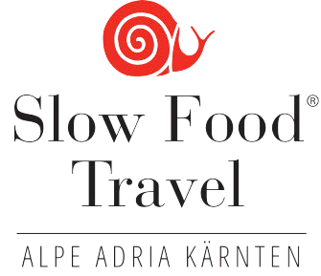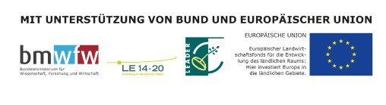

LOGO FOR INDICATION - PRODUCERS AND HOSPITALITY FACILITIES
(for the rules on use of the logo by producers and hospitality operators, check the specific document)

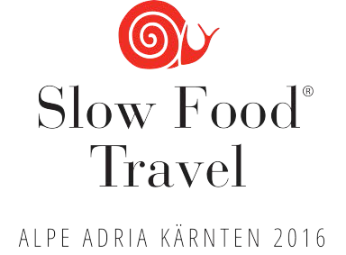

SLOW FOOD TRAVEL LOGO

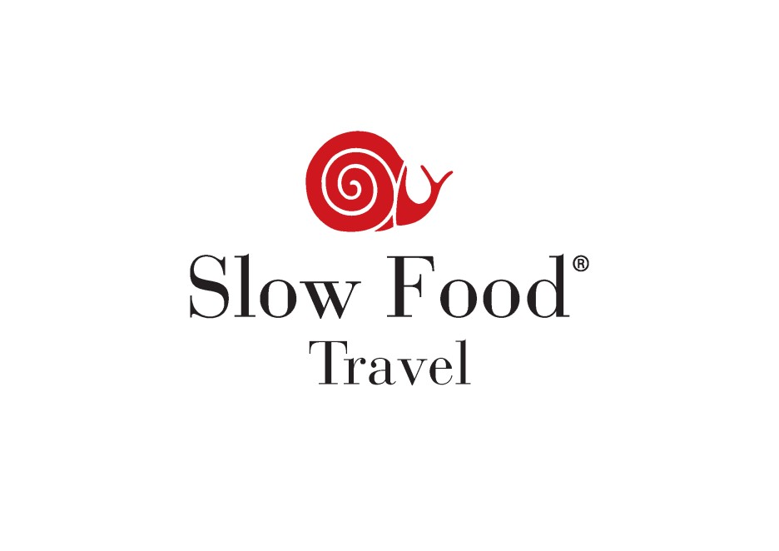

LOGO TEMPLATE AND BRAND LICENSING RIGHTS FOR SLOW FOOD TRAVEL
After completing preparatory work with Slow Food International (www.slowfood.com), the LOGO has been released for use. SLOW FOOD TRAVEL international trademark is therefore available for the project partners, initially just for a one-year period of validity.

THE “SLOW FOOD TRAVEL” TRADEMARK

- The trademark (logo) functions as a kind of beacon to recognize the “Slow Food Travel“ program. It guarantees recognition in the various media, and is a central link between the "Slow Food Travel" project brand strategy and its identity. The trademark will be used in all media and publications.
- The logo integrates the existing Slow Food Travel brand into the "ALPE ADRIA KÄRNTEN" (ALPS-ADRIATIC CARINTHIA) regional concept, in a complimentary relationship. The "Slow Food Travel Alpe Adria Kärnten" logo usage is limited to the partners from the NLW project region during the 2015 - 2018 project duration.

LICENSING RIGHTS AND USAGE GUIDELINES

- Slow Food International owns the "Slow Food Travel" brand. As the "Slow Food" logo is part of a trademark registered in the European Union, also the derived trademarks are protected.
- The document "Code of Use for Slow Food Trade Mark" (Torino 2012), which contains detailed logo guidelines, is a supplement to Slow Food Travel general rules.
- The "Slow Food Travel" brand is bound by the requirements set out in this manual.
- The ARGE cooperation group may use the logo without

adding the date of the current year.
    - The cooperation group partners are entitled to use the logo only with the current year added.
    - The "Slow Food Travel Alpe Adria Kärnten" logo can be only assigned by the project cooperation group, initially limited to the pilot phase period.
    - In case of non-compliance with the criteria laid down in the cooperation agreement, Slow Food International can revoke the usage of the brand.
    - Any use of the logo by the Slow Food Travel cooperation group shall be submitted to and approved by Slow Food International in writing.
    - The logo shall not be handed over to or used by people and organizations that are not involved in the regional Slow Food Travel project (= partners of the Slow Food Travel cooperation group).
    - In any case, the "Slow Food Travel" brand and the "Alpe Adria Kärnten" shall not be used by members of the SFT AAK cooperation group without authorization. In each case, the cooperation group’s specific written approval is needed upon request of a partner/company and after subsequent verification that criteria have been fulfilled.
    - The logo shape shall not be changed. Compliance with the correct shape and size proportions shall be ensured.
    - Neither the "Slow Food" logo nor the derived trademarks like "Slow Food Travel" may be reproduced on products or packaging.
    - The general "Slow Food" logo (snail + Slow Food) shall not be used.
    - The "Slow Food Alpe Adria" regional convivium has its own authorized logo.
    - In case of failure to comply with the brand licensing rights, any advertising or other types of communication as well as online publications shall be withdrawn from the market/internet.

Page | 49

PRACTICAL USE
The logo 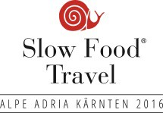can be displayed on all printed materials and online publications in which the Slow Food Travel program is presented or announced. The prerequisite is continous membership in
good standing, and in cooperation with Slow Food Travel Alpe Adria Kärnten cooperation group, which includes membership with the "Slow Food Alpe Adria" regional Convivium.
Compliance with the criteria of "Slow Food Travel Alpe Adria Kärnten" is also mandatory.

PROTECTION ZONE FOR THE TRADEMARK:
When using the logo, make sure it is prominently published in its current form (with year of date). A free space/protection zone around the trademark is essential not to impair the visual impact. Said space should be at least 10% of the logo format.
Example: If the displayed logo is 5 cm wide and 4 cm high, the lateral free space shall be 5 mm and the top and bottom free space 4 mm (grey edge zone).

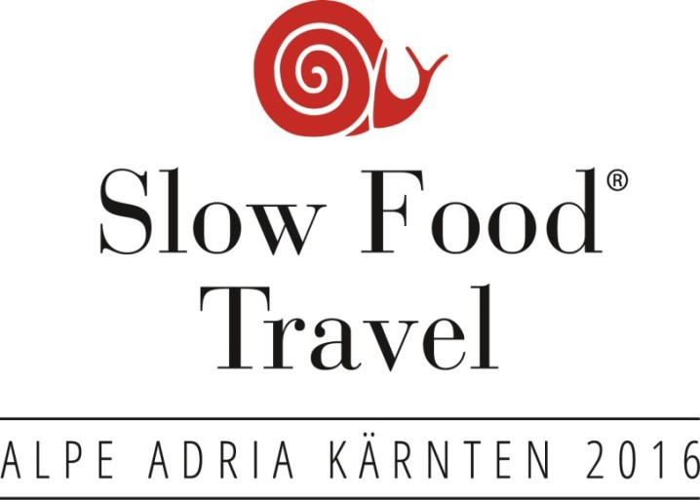
THE MINIMUM SIZE OF THE TRADEMARK SHALL BE 30 MM WIDE.

BACKGROUND TO THE TRADEMARK:
The trademark basic version is preferred on a white backdrop.

The negative variant is preferably used on colored backgrounds. Placement and contrast along with readability are also important.
EXAMPLE: COLORED BACKGROUND - USE THE NEGATIVE VERSION.

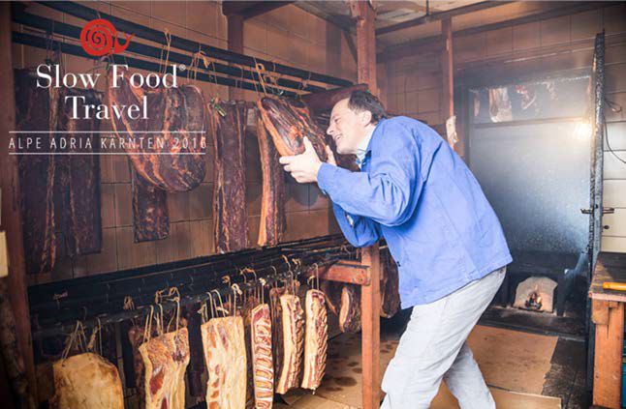

TRADEMARK PLACEMENT:
Please make sure that the trademark is used in clearly displayed, readable spots on the advertising material and is not placed somewhere on the outer edge.
BEFORE PRINTING OR PUBLISHING, THE DRAFT SHALL BE RELEASED BY SLOW FOOD TRAVEL MANAGEMENT COMMITTEE.

Please send your submissions to info@mandler.info.

European Commission – Greek Authorities, Plan for technical cooperation in support of structural reforms
C. Tisdell et al, Nature-based Tourism and Conversation
SETE, Greek Tourism 2020, Proposal for the new development model.
http://www.visitgreece.gr/en/greek_islands
EUROPEAN COMMISION – Agriculture and Rural Development, Common Agricultural Policy (CAP) in Greece
http://www.visitgreece.gr/en/nature/forests
EUROPEAN COMMISSION - Maritime Affairs Policy Research Corporation, The economics of climate change adaptation in EU coastal areas
http://geodata.gov.gr/en/dataset/to-diktuo-natura-2000-kai-prostateuomenes-periokhes
EUROPEAN COMMISION – Agriculture and Rural Development, Common Agricultural Policy (CAP) in Greece
http://ec.europa.eu/eurostat/statistics-explained/index.php/Agriculture_statistics_-_family_farming_in_the_EU
http://ec.europa.eu/eurostat/statistics-explained/index.php/Agricultural_census_in_Greece#Main_statistical_findings
EUROPEAN COMMISION – Agriculture and Rural Development, Common Agricultural Policy (CAP) in Greece
https://ich.unesco.org/en/RL/mediterranean-diet-00884
http://www.blueflag.global/all-bf-sites/
http://www.greenkey.global/green-key-sites/
https://www.tripadvisor.co.uk/Attractions-g189398-Activities-Greece.html / https://tinyurl.com/ycyxxpm3
http://news.gtp.gr/2017/06/20/booking-com-greece-top-global-food-destinations/ / http://news.gtp.gr/2017/06/21/hotrec-quality-cuisine-greece-europes-top-3-foodie-destinations/
http://agroxenia.net/en/farms_view_en
http://eu.greekreporter.com/2016/12/14/greek-tourism-to-be-promoted-in-big-scandinavian-fair/
http://www.unesco.org/education/tlsf/mods/theme_c/mod16.html
UNEP, Making tourism more sustainable - A guide for Policy Makers
http://sdt.unwto.org/content/about-us-5
EUROPEAN PARLIAMENT, Briefing - Sustainable tourism
DESTINATION EUROPE, Long-Haul Travel Barometer - Edition 8 - 2017
UNEP, Making tourism more sustainable - A guide for Policy Makers
UNEP, Making tourism more sustainable - A guide for Policy Makers
SLOW FOOD, The Ark of Taste
http://ec.europa.eu/agriculture/quality/door/list.html?locale=en&recordSelection=all&recordStart=0&filter.dossierNumber=&filter.comboName=&filterMin.milestone__mask=&filterMin.milestone=&filterMax.milestone__mask=&filterMax.milestone=&filter.country=GR&filter.category=&filter.type=&filter.status=
UNWTO, Global report on food tourism
M. del Pilar Leal Londoño, Gastronomy Tourism: An Opportunity for local development in Catalonia?
EMBACHER H., Holidays in Austria - Strategy and Contributions towards Sustainability / EMBACHER H., Marketing for farm holidays in Austria
AUSTRIAN MINISTRY OF AGRICULTURE, Urlaub am Bauernhof Rechtliche Aspekte Vers. 14_04_2014 / STATISTIK AUSTRIA, Agrarstrukturerhebung 2013
http://www.socialprogressimperative.org/custom-indexes/european-union/?area=EL24#scorecard/components/euregional/
http://ec.europa.eu/eurostat/statistical-atlas/gis/viewer/?year=&chapter=10&mids=2,76&o=1,1&center=38.87682,28.61469,4&nutsId=EL64&

